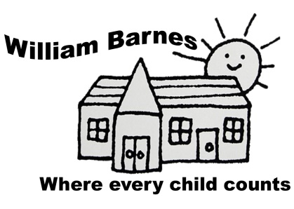
William Barnes Primary School
English Policy
Generic INTENT

Vision |  |  | Mission
*An inspirational, stimulating and well-resourced environment  *A safe and secure school at the heart of the community  *Inquiry, independence and enthusiasm for learning |  | *Preparing all children for life  *A high quality professional team  *Taking pride in all our achievements  *High standards of behaviour | Where every child counts
Excellent teaching gives children the life chances they deserve...Enjoyment is the birthright of every child. The most powerful mix is the one that brings the two together. Children learn better when they are excited and engaged – but what excites and engages them best is truly excellent teaching. Education is for all, not the few. All children have the right to be the best they can be. We foster a love of learning and the development of the well-rounded child.
Preparing Children for Life
We believe that we are preparing children for 21st Century life. We aim for them to be independent thinkers, confident learners and global citizens, equipped to live and work in and contribute to the global economy.

Aims and Objectives
At William Barnes Primary School, we believe that children deserve:
- To be set appropriate and stimulating learning challenges
- To be taught well and be given the opportunity to learn in ways that maximise the chances of success
- To be given quality feedback which highlights successes and areas for improvement.
- To have adults working with them to tackle the specific barriers to progress they face.
It is also our aim that :
- Children develop a lasting love of all aspects of learning which will aid and enhance their further education and life.
- Children are given the opportunity to experience the widest variety of the written and spoken word possible - a vocabulary rich curriculum and school experience. This includes trips to pantomimes, art galleries and orchestral concerts.
- Children develop a healthy lifestyle this is supported by Active Learning, The Daily Mile, Wake and Shake and a robust healthy eating policy.
Knowledge and Skills
As a school, we believe in the equal relationship between knowledge and skills in our curriculum.
We believe that:
- Knowledge can be declarative ( to know that ) or Procedural ( to know how ).
- Both these forms are important and that Declarative knowledge is turned into Procedural knowledge.
through action and the act of applying.
- Skills can be Procedural knowledge as a result of the application of Declarative knowledge.
- Skills can be linked to dispositions and behaviours.

In short, skills often procedural knowledge and are linked intrinsically to declarative knowledge.
We prefer to see the debate laid out as:

Knowledge Comprehension Application Evaluation

Global Community  We aim to equip our children for living in, and contributing to, a secure, transformative and sustainable world. | Parents  “For all children, the quality of the home learning environment is more important for intellectual and social development than parental occupation, education and income. What parents do is more important than who parents are.” (EPPE)

English INTENT

Introduction
The National Curriculum (2014) clearly states that teaching the English language is an essential role of a Primary School.

The new English programme of study is based on four areas:

Spoken Language | Reading  (Word reading and Comprehension)
Spelling, Grammar and Punctuation | Writing  (Transcription, Composition, Handwriting and Presentation)

The curriculum is divided into 3 Stages;
EYFS, Key Stage 1 (Year 1 and 2), Lower Key Stage 2 (Year 3 and 4 ) and Upper Key Stage 2 (Year 5 and 6)

By the end of each Key Stage, pupils are expected to know, apply and understand the matters, skills and processes specified in the relevant programme of study.

Current Practice

- All teachers and teaching assistants follow the National Curriculum 2014.
- Long term planning outlines text focuses which are placed to maximise cross curricular potential.
- Long term planning outlines spelling, grammar and punctuation focuses.
- Medium Term planning outlines text focuses as part of the connected curriculum.
- Weekly planning contains learning objectives, success criteria, opportunities for all children to access the curriculum through a variety of different contexts and direct planning for Teaching Assistants.
- Spelling ages are tracked on an annual basis.
- Reading ages are tracked on an annual basis.
- There is a rigorous and effective system for tracking children’s progress in phonics, reading and writing throughout the school on a half-termly basis. (see assessment)
- All teaching of English is infused with the Assessment for Learning Strategies developed by the school.
- Teachers create a balance between shared, guided and independent reading and writing throughout a week.
- There is a high priority given to the use of experiences across the curriculum as a stimuli for language and writing.
*

Spoken Language
The National Curriculum states that pupils should be ‘taught to speak clearly and convey ideas confidently in Standard English’ (p10). They should:
Justify ideas with reasons | Ask questions to check understanding | Evaluate and build on the ideas of others
Negotiate | Develop vocabulary and build knowledge | Select the appropriate register for effective communication
Organise their ideas prior to writing | Speculate, hypothesise and explore ideas | Give well-structured descriptions and explanations

Developing strong speaking and listening skills is fundamental to the teaching of English and all subjects at William Barnes Primary School. All staff are very aware of the research around the vocabulary gap and its consequences for learning in the short and long term and practice has been influenced by the 2018 publication of ‘Closing the Vocabulary Gap’ by Chris Quigley. Teachers place a high emphasis on spoken language, oracy and vocabulary and plan for the discreet teaching of skills as well as incidental learning opportunities. A number of strategies have been introduced to support this catch-up.
- The Oracy/Vocabulary Scheme of Work has been created for all year groups to promote the closing of the vocabulary gap, the development of vocabulary and understanding and the development of quality speaking and listening skills. Vocabulary Ninja is used by the whole school to support the scheme.
- The Oracy Programme is led by well-trained Teaching Assistants and outside agencies. It is focussed on key children in Reception and Year 1 and uses a number of programmes to develop language, oracy and vocabulary skills (Communication Supporting Classrooms Observation Tool, The Early Years Developmental Journal and the WellCom pack.
- Talk Tuesday is a termly event where lessons continue as normal but the emphasis is on oracy, vocabulary and language as there is no recording by children whatsoever. It was designed as a platform for developing strategies which should then appear in everyday teaching.
- Vocabulary posters are on display around the school which encourage children to challenge unknown vocabulary in any context.
- Children’s speaking and listening skills are supported by the use of formative questioning strategies throughout the school.
- Quality talk is valued, given high priority and managed appropriately throughout the school.
- The regular use of Talk Partners.
*

Reading

- Pupils throughout Foundation Stage and Key Stage 1 follow a rigorous and systematic teaching programme of synthetic phonics through the Floppy's Phonics scheme. The scheme is supported with a wide range of Decodable reading books for our early readers. Some children who move in to Key Stage 2 who still need further phonics learning have interventions using the same Floppy’s Phonics approach and resources delivered by trained staff. Decodable reading books that support developing fluency are sent home alongside phonics consolidation activities weekly in Reception and KS1. Children also bring a book home from the school library and visit the town library termly. KS2 pupils who are still on their phonics journey have access to decodable readers specifically written to engage older readers.
- Guided Reading and Reading Workshop is an established part of the day in all classes.
- Reading Journals are used throughout the school as a means of recording reading and interacting with/responding to texts as part of home reading.
- The school uses a colour coded reading scheme throughout Key Stage 1 and 2. All children learning phonics have phonetically matched, decodable books which match our Floppy’s Phonics Scheme. The primary scheme and the basis for colour coding is The Oxford Reading Tree.
- The Literacy Toolbox and Rapid Readers are embedded interventions for developing reading skills with children who are not at Age Related Expectations.
- The School Library has been developed to include Non-Fiction Books and sets of Fiction Books. All classes have timetabled Library time and regularly change their Library books.
- Year six are actively engaged as Reading Guardians, supporting children who require more reading throughout the school.
- We have a strong culture of Parent and Community Reading Volunteers.
- Year six are actively engaged as Phonic Friends, supporting year 1 children requiring more practice developing their phonic skills.
- All classrooms have a designated Book Area, and books are stored and displayed attractively to entice readers. In higher age groups, as well as the colour codes as a criteria for grouping, they are also grouped by author, genre or theme.
- The purchase of new reading materials is constantly being reviewed, with funding coming from donations, Book Fair revenue, the PTFA, donations and basic capitation and The Cornerstone English Hub.
- The school runs termly Book Fairs for parents and children. These are in line with Parents’ Evenings where parents are encouraged to attend meetings and visit classrooms and lessons.
- The school actively engages with World Book Day in a positive, book-orientated manner, promoting new texts, a love of listening to stories and breadth of reading material.
- The Morning Read has been set up as an opportunity for parents to use the library to hear their child read for 20 minutes before school.
- Reception and Year One have regular Phonic Mornings, where parents come into the classroom and participate in a phonics session.
- Lessons With Parents is a strategy which will be developed throughout the school.

Reading Provision Map
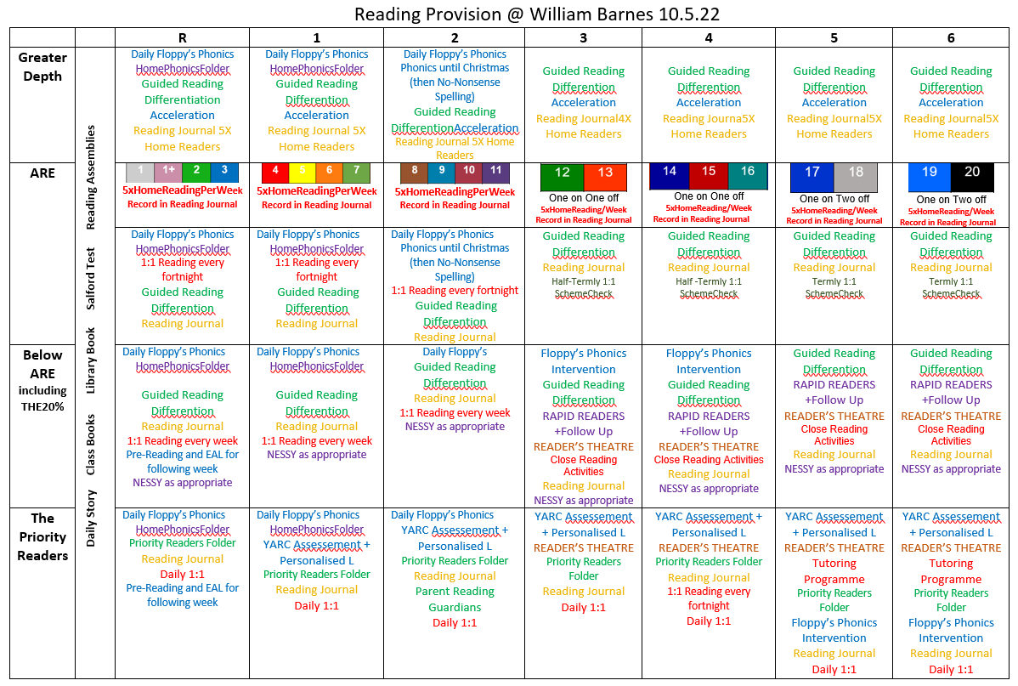

Phonics and Early Reading

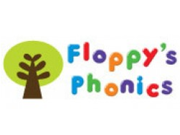

Phonics and Early Reading
In line with the latest evidence based research into the way young children learn to read, we have made significant changes to the way in which we use and issue reading books for all children who are learning phonics at the school and have purchased many new, decodable reading books.

Project aims:
To ensure that all books used to develop reading skills directly match the phonics knowledge that the pupils are being taught.

To increase fluency of reading by using books that only have phonics that the children are secure with and that build on prior learning.

Rational:
Our existing scheme needed more books to support learning at Stage 2-3
Our existing scheme had a number of books at each level that did not match the phonics being taught.
Many books in our existing scheme did not align with our DfE Validated Floppy’s Phonics scheme of learning.
‘reading books should show a cumulative progression in phonics knowledge’
‘Reading books should closely match the phonics knowledge that pupils are being taught and you should offer them plenty of opportunities to practise reading and re-reading the grapheme-phoneme correspondences that they have learned’
(New 2019 Ofsted Framework)

All our scheme reading books are phonetically matched to the correct Floppy’s Phonics Stage. Children should know all the phonemes in the books they are given.
Each Stage also has Floppy’s Phonics Sounds books to be used for teaching, consolidation and intervention, alongside the online Floppy’s Phonics resources which can be access on all laptops and iPads.
Order of books:
Level 1 (Stage 1 Floppy’s Phonics)
Wordless books
Level 1 + (Stage 1+ Floppy’s Phonics)
First: Floppy’s Phonics Decoding Practise Level 1+ in order as sounds learnt
Further practice: Bug Club and/or Hero Academy
Level 2 (Stage 2 Floppy’s Phonics)
First: Floppy’s Phonics Decoding Practise Level 2 in order as sounds learnt
Further practice: Word Sparks Level 2 and/or Hero Academy
Level 3 (Stage 3 Floppy’s Phonics)
First: Floppy’s Phonics Decoding Practise Level 3 in order as sounds learnt
Further practice: Word Sparks Level 3 and/or Hero Academy Level 3
Level 4 – (Stage 3 Floppy’s Phonics and consonant clusters)
First: Floppy’s Phonics Decoding Practise Level 4 (The Camping Trip/Fantastic Things…)
Further practice: Hero Academy Level 4 and/or Floppy’s Phonics Fiction Level 4
THEN: Stage 4 Floppy’s Phonics- preparation for Phase 5)
First: Remaining titles from Floppy’s Phonics Decoding Practise Level 4
When children are secure with all Stage 5 Floppy’s Phonics and are reading with fluency from Stage 4 books they can progress to Level 5 books:
First: Floppy’s Phonics Decoding Practise Level 5
Then: Hero Academy Level 5 and/or Floppy’s Phonics Fiction Level 5
The Floppy’s Phonics Decodable readers can be used as further practise books for group reading, as an alternative to the Sounds books and issued to take home as sounds are taught for children who are reading fluently within all sounds that are taught, otherwise books will be issued at the correct fluency level, which for many children will be the level below their current phonics learning stage.
Traditional Tales books are used at the end of each Phonics Stage for Guided Reading group fluency practice.

Writing

- Writing is marked using formative success and improvement marking whenever appropriate and
there is a marking code followed throughout the school.
- Dedicated Improvement time is a regular practice throughout the school.
- The school has a clear Editing Policy, which supports child-led improvement to a first draft of substantial writing. Editing partners support each other with paired-peer editing
- All year groups from R onwards use a Writer’s Workshop Book to document progress and breadth in children’s writing. The book follows the child through the school. All substantial writing from any area of the curriculum is added to this compendium of their work. It is a regular opportunity for writing which may involve choice and independence. The Writers’ Workshop book should be marked in line with the marking policy and is an excellent opportunity to mark formatively. It is also an excellent link with home.
- HomeTalkSchoolWrite (HTSW) is now embedded practice. On a monthly basis, a writing task is sent home on a Monday to be discussed with parents in preparation for independent writing on Fridays. Time is given to children struggling with home support through the week from Teachers and Teaching Assistants. A copy of the unmarked work is then sent home.
- The Long Term Plan for writing shows that teachers have separated elements of the curriculum across the 3 terms, where appropriate. Existing genres for writing are flexibly used across 3 terms but with reference to cross curricular opportunities.
- The school has adopted the Cranborne Handwriting Scheme which is supplemented by online ‘Teach Handwriting’.
- Listening to stories is given a high priority throughout the school.
- The use of Writing Targets for sentence level work is in operation across the school. Layered targets should be displayed prominently in all classrooms. Across the school, the targets are exemplified with relevant sentences which reflect the current text type.
*
GPAS
- At William Barnes, we believe that Grammar, Punctuation and Spelling should be taught in context of meaningful reading and writing activities but also discretely. To facilitate this, short, specific lessons on grammar, word level and punctuation are taught outside of the English lessons.
- GPAS teaching is supported by the No-Nonsense Grammar Package and the No-Nonsense Spelling Package.
- A variety of GPAS teachers’ resources have been purchased to support the coverage of the curriculum and the year group specific expectations. They are used to supplement the exciting, creative lessons teachers devise to engender a love of grammar with their children.

SPELLING
The new National Curriculum states that:
It is essential that teaching develops pupils’ competence in the following 2 dimensions.
transcription (spelling and handwriting)
composition (articulating ideas and structuring them in speech and writing)

*
As children move from Key Stage 1 to Key Stage 2, the emphasis shifts from the teaching of phonics to the teaching of spelling strategies, conventions and rules and build on children’s phonological knowledge. Key Stage objectives are taken from the year group expectations in the Curriculum 14 and Support for Spelling and the older Spelling Bank are used as aids for teaching and effective activities. There is one dedicated Word Level session each week. All children are encouraged to use their knowledge of phonics and the Alphabetic Code Chart to aid spelling choices.
Children who still require phonic knowledge for reading and spelling will have dedicated intervention time for this.

All children are tracked on a yearly basis, using the NFER Single Word Spelling Test.

Misspelt Keywords from Curriculum 14 (3/4, 5/6) are displayed, with a selection used as a weekly focus in word level lessons.

Interventions
Where children are not making enough progress or are struggling with aspects of spelling, a number of interventions are used throughout the school.
Phonic Intervention – Key stage 2 may require further phonic learning. The Phonic Screening Test, Floppy’s Phonics Assessments, the NFER Single Word Spelling Test and children’s spelling in independent writing are all used to assess whether children should have phonic intervention. Children may have up to 3 sessions a week in small groups.
Other spelling interventions used where appropriate – Nessy, Toe by Toe, SNIP and Teodorescu.

- The school uses and is building up a set of mnemonics for key words, which are displayed in classrooms and around the school.
- There is a high expectation amongst staff for quality vocabulary when writing. The Dash-it, Don’t Dodge Posters in each class promote the use of higher order vocabulary without the fear of spelling errors.
- There is also a high expectation for copying words correctly and using dictionaries, displays and word banks with accuracy. The Acceptabubble Posters promote this expectation and are displayed in all classrooms and around the school.

Planning

- Long term and medium term planning is in line with Curriculum 2014 and is used as part of the connected curriculum.
- Each term a class will be taught a mixture of fiction, non-fiction and poetry units as well as a Take One Poet or Take One Book focus.
- Weekly planning follows an agreed proforma and generic principles.
- Broad Learning Intentions from Curriculum 2014 are broken down in the smaller, appropriate
Learning Intentions. Success Criteria, required exposition and linked differentiated activities are also
included.

Agreed Cursive Handwriting Development
Reception
Use of Guidelines  www.teachhandwriting.com  Route C Choice 3  Secure Letter Formation with a slight lead out | Use of Guidelines  www.teachhandwriting.com  Route C Choice 3  Secure Letter Formation with a slight lead out | Use of Guidelines  www.teachhandwriting.com  Route C Choice 3  Secure Letter Formation with a slight lead out
Year 1
Use of Guidelines  www.teachhandwriting.com  Route C Choice 3  Secure Letter Formation with a slight lead out | Use of Guidelines  www.teachhandwriting.com  Route C Choice 3  Secure Letter Formation with a slight lead out | Use of Guidelines  www.teachhandwriting.com  Route C Choice 3  Secure Letter Formation with a slight lead out
Year 2
Use of Guidelines  www.teachhandwriting.com  Route C Choice 3  Secure Letter Formation with a slight lead out | Use of Guidelines  www.teachhandwriting.com  Route C Choice 3  Secure Letter Formation with a slight lead out | Use of Guidelines  www.teachhandwriting.com  Route C Choice 3  Secure Letter Formation with a slight lead out Cursive for the more able.

Year 3
www.teachhandwriting.com Route C Choice 3  Cursive  with intervention | www.teachhandwriting.com Route C Choice 3  Cursive  with intervention | www.teachhandwriting.com Route C Choice 3  Cursive  with intervention
Year 4
Cursive  with intervention | Cursive  with intervention | Cursive  with intervention
Year 5
Cursive  with intervention | Cursive  with intervention | Cursive  with intervention
Year 6
Cursive  with intervention | Cursive  with intervention | Cursive  with intervention

Less whiteboards for all writing
No Guidelines in KS2 unless there are fine motor difficulties
Use of highlighter band for support where necessary
(the width of the highlighter gauges the height of general letters
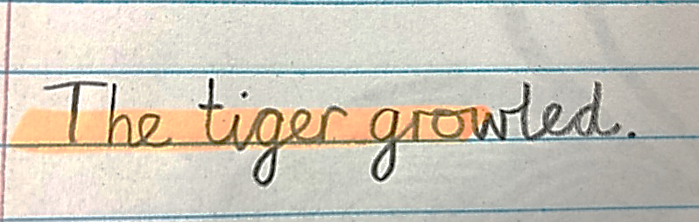

OVERVIEW
Writing Text Types Across the School

Reception
 | Autumn | Spring | Summer
Fiction | Stories with predictable structures and patterned language. Traditional tales  Preforming – The Christmas Gingerbread Man – Story Making | Stories with predictable structures and patterned language. Traditional tales | Stories with predictable structures and patterned language.
Non-fiction | Cards- Writing Christmas cards.  Letters- Writing a letter to Santa.  Name cards  Lists and labels | Letters- Thank you letter to Santa  Names cards, lists labels.  Information texts-  Invitation- to a party or an event in reception. | Letter-Thank you letter to the Easter Bunny  Instruction Writing- how to make a jam sandwich
Poetry | Nursery rhymes and nursery- rhyme stories  Poetry Day | Action verses and counting rhymes  Poem for Mother's Day | Poems and chants

Year One
 | Autumn | Spring | Summer
Fiction | Stories with familiar settings Dogger, Knuffle Bunny, The Tiger who came to Tea | Superheroes  SuperDaisy, Supertato, Superkid  Comic strip  Traditional Tales  The Three Billy Goats Gruff  Innovate a traditional tale | Aliens love underpants  Books by Oliver Jeffers focussing on Lost and Found
Non-fiction | Information Texts  Vlad and The Great Fire of London  Different books and online texts about the Great Fire of London  Recount  Diaries linked to Samuel Pepys | Information  Florence Nightingale and Mary Seacole  Animals | Explanation  How to plant a seed  Information – country study linked to Olympics (if on)  Recount – linked to Sandbanks Trip
Poetry | Poetry Day  Senses poems linked to Bonfire Night  Nursery Rhymes | The Owl and the Pussycat  Performance Poetry | Where the Wild Things Are  Traditional Rhymes

Year Two
 | Autumn | Spring | Summer
Fiction | Dreamtime Stories & Magic Key stories | The Tunnel – imaginative stories  Whatever Next! - changing story elements | Traditional Stories & Animal stories
Non-fiction | Letters  & Comparison Reports | Diary Entries, Recounts, Instructions and Factfiles | Information books
Poetry | Poetry Day  Bio Poems |  | Performance Poetry & Growing Up rhyming poems

Year Three
 | Autumn | Spring | Summer
Fiction | Roald Dahl – character descriptions/diary entries/playscripts | Narrative – extended story – magic key  The Iron man - summary | Rio – character/setting description  Narraritve – magic fruit
Non-fiction | Newspapers/nonchronological report | Instructions | Persuasive posters  Instructions
Poetry | Rhyming couplets  Poetry Day | Robot themed | Haiku and Cinquains

Year Four
 | Autumn | Spring | Summer
Fiction
Non-fiction
Poetry

Year Five
 | Autumn | Spring | Summer
Fiction | Extended adventure story – Greek Myth | Wind in the Willows – write a missing scene - character portraits | Stories from Other Cultures – Rona Long Teeth
Non-fiction | Instructions – How to make Hummous  Information writing – Ancient Greek Gods  Persuasive Posters – Ancient Greek theme park | Letters – thankyou to Leeson  Explanations – Leeson House  Cohesive paragraphs - Mountains | Playscripts – There's a boy in the girl's bathroom  Information writing – Ancient Greek Gods
Poetry | Comparing Micheal Rosen and Ted Hughes | Narrative poetry – the Highwayman | Poetry – Descriptive language and imagery

Year Six
 | Autumn | Spring | Summer
Fiction | Narrative: Chillers | Narrative:NSPCC Story | Narrative: Boy’s Story (RSPCC/Childline)  Setting Description (Kenya/Nairobi)
Non-fiction | Description of a Painting  Personal/Expressive (Maslowe’s Triangle)  Persuasive: Everyone Should Go To PGL…  Information | Letter of Thanks/Pantomime  Letter of Complaint  Information: Monsters  How to Survive : ??? | Letter of Application (Summer Jobs) Description of Football Boot  Description of a Painting
Poetry | Poetry Day  Haiku/Cinquains | Metaphor Poetry

IMPLEMENTATION

How We Teach

At William Barnes Primary School, there is at least an hour each day dedicated to the teaching of English.
This may be dedicated to spelling, phonics, grammar, reading focus or writing. Children are grouped by year and there is differentiation evident where appropriate. Assessment for Learning Strategies are used throughout lessons to inform children and adults of progress and understanding and a clear marking policy is used to further inform.
Reading/Vocabulary/Oracy
We believe reading to be the very bedrock for learning. Reading development is considered at every learning opportunity and opportunities for developing the reading practice of children and parents are constantly being updated. We are constantly evaluating new and existing strategies for encouraging home reading.
Time is given to vocabulary development within all subjects and children are encouraged to question new vocabulary at any opportunity. As stated before, we run our own Oracy Project, which supports the catch up process for young children with a vocabulary gap.
Personalised Learning
Where it is evident that a child has not grasped the skill/knowledge in a particular lesson, a personalised learning session will be set up to support the child. This is run by Teaching Assistants.
Personalised Learning is also given as dedicated time that is used to support children who are Pupil Premium.
Long Term Learning
As a staff, we are committed to the idea of Long Term Learning; skills should be taught and built upon, revisited and revised and that all English skills, be they Reading or Writing inform the whole English Learner.

Support

Professional support for staff in English takes on many forms:
- The English Coordinator has access to County Coordinator Briefings on a termly basis and the school is now affiliated to the Cornerstone English Hub.
- All teachers in Year 6 and Year 2 regularly attend Assessment Briefings and also Moderation Meetings to support the Teacher Assessment of Reading and Writing.
- Any teachers new to KS1/KS2 Teaching Assistants will be trained in Phonics teaching and any new to a statutory assessment year, will also have access to key training.
- Year 6 and Year 2 teachers also connect with Pyramid colleagues for more moderation of Reading and Writing.
- There are regular staff meetings for English updates and regular moderation sessions where decisions are made on standards and progress.
- There are strong links with County Support Teams who support our Oracy Project, helping with resources and ideas and supporting children with Speech and Language barriers.
- SENSS support staff and children with diagnosis of English based Learning Difficulties.
- As a staff with much experience, there is constant support from within – be it ad hoc, or as part of our Paired Teaching Programme, where teachers choose a shared focus (eg. Guided Reading) and observe one another.
- One-off courses are chosen with care, and only when focussed on an aspect of the School Development Plan for English.
- Writing standards are monitored regularly by the SLT team and professional and supportive feedback is given

Parents
At William Barnes Primary School, we believe that parents and teachers working together is highly beneficial to long term quality learning.

We ask parents to be as involved as possible in the following areas of the English Curriculum:
- Regular Home Reading
- HomeTalkSchoolWrite preparation for writing once every month.
- Supporting Phonics and Helpful Words (‘tricky words’) retention
- The Morning Read
- Parents’ Meetings for information
- Parent Reading Guardians

We also involve parents around the English Curriculum with:
- Open lessons, where parents may come and join in/support
- Family Learning Week activities

IMPACT

Assessment
Summative assessment

- Foundation Stage children are assessed throughout the Reception year leading to the CLLD element of the Foundation Stage Profile.
- All children in R to Y6 are tracked with Tracking Points, using Online Educater in Reading and Writing.
- Aspirational targets are set at the beginning of each year based on a mixture of summative
assessment, teacher assessment, and transition discussions between teachers and
teaching assistants.
- Children are assessed throughout the year and summatively at the end of each half term. Online Educater will be used to make these judgements. Children are judged to be... On track /Not on track to achieve their target and age related expectations. Reviews are written for children who are not on track, explaining the issue and action to be taken.
- Writer’s Workshop books, cross curricular writing and independent writing are used as a source of
evidence to support judgements.
- There is a strong culture in the school regarding the moderation of writing – regular sessions take place to moderate judgements, year group expectations and individual’s work to ensure that there is consistency across the school.
- YARC(Reading) and YASP (Spelling) assessments are used for the diagnostic assessments of children with SEND. This is followed up by personalised learning.
- We are an outward facing school and regularly moderate with other schools.
- Possible interventions include
The Oracy Project | 1:1 Reading/Specific Schemes | Handwriting | Rapid Readers
Teodorescu Spelling | Catch-Up Spelling | Speed Writing | SNIP Spelling
Literacy Toolbox | SENSS follow-up/support | Reading Guardians | Phonic Friends
Dandelion Readers | Precision Phonics | NELI
Individual Programmes and recommendations from outside agencies are implemented by Teaching Assistants alongside teachers.

- SATs tests are analysed by the Headteacher and the coordinator for trends, particular groups and areas requiring development.
- All children’s reading is assessed on a yearly basis, using the Comprehension Reading Test and recorded. This gives a reading age and a comprehension age to compare. Intervention strategies are used as a result of this analysis as well as class groupings and expectations and they are monitored by the Headteacher.
- All children’s spelling is assessed on a yearly basis using the SWST.
- All children in Year 2 take the CATS Test to support teachers’ assessment of underlying ability.

Formative Assessment
AFL strategies are embedded across the school and several strategies / beliefs apply to the ongoing assessment of English:
- Personalised intervention time is given as immediate feedback to individuals requiring it as well as to Pupil Premium children as dedicated time.
- The use of visualisers for immediate, within lesson feedback is used throughout the school.
- Random questioning in English lessons is used to support assessment of understanding and to promote engagement.

SEND/Vulnerable Groups/EAL

Children with SEN in English (those children who have barriers to their learning) are identified on the school’s tracking system. These children may be taught 1:1 for specific skills or work in a small group inside or outside the classroom. They may be referred for SENSS assessment or Speech and Language Therapy and receive SENSS support. They will have an IEP and work toward specific targets. The IEP may be for elements of reading, speaking and listening or writing.
There is a dedicated Teaching Assistant for specific support for EAL children. This is focussed on the most needy children and withdrawn slowly as they gain an understanding of English.
Disadvantaged (Pupil Premium) children are monitored very closely, identified on planning sheets and their specific data is analysed half termly.
YARC and YASP ensure highly personalised intervention and the Tutor Programme has been targeted towards Year 5 and Year 6 Pupil Premium children.

Equal Opportunities

- English is taught within the framework of the school’s equal opportunities policy.
Special educational needs and disabilities:

* Children with AEN, SEN and Higher Achieving Children will have activities differentiated to their
individual needs.
* Children with SEN should have an IEP detailing targeted support.
* Weekly planning should be sufficiently differentiated to cover their needs.
* Practical resources may need to be available especially in Reception and Key Stage 1.
* All teaching staff must ensure that they support these children during the week for literacy.
* Specific skills for literacy will be on the IEP and additional time needs to be available for the teaching
of these.
* It is important to note that a child who finds numbers difficult may not struggle in all areas of the
English curriculum
- Children who have been impacted by Covid lockdowns and absences due to illness are supported with catch-up.
Governors

- There is a member of the Governing Body with overall responsibility for English.
- Whole school attainment data for English is shared with the Governing Body.
- Governors are kept up to date with any developments/decisions at Governing Body meetings.

Class based/Cherished texts.

It is the intention to equip each class with a set of one text for shared class reading sessions.

 | YR | Y1 | Y2 | Y3 | Y4 | Y5 | Y6
Class Reader Collections | Brown Bear Brown Bear | The Tiger Who Came to Tea | Gorilla  The Owl Who Was Afraid of the Dark | Friend Or Foe | Journey to Jo’burg. | Stig of the Dump  Harry Potter  1 | The Butterfly Lion  Cat Burglar

Policy Appendices

Formative Feedback | Guided and Shared Reading and Writing | Challenge/Extended  Writing | Whole School Sentence Targets
Reading Guardians  Phonic Friends | HTSW | Editing Policy | Extended Writing

Future Developments

- Develop Library Provision – School Library enhanced with displays, seating, electronic system
- Town Library Visits
- Development of The Oracy/Vocabulary Scheme throughout the school
- Ongoing training of all staff in the Floppy’s Phonics approach and developing reading fluency
- Decodable readers for Key Stage 2
- Continued involvement with the English HUB
- Continued development of Key Stage 2 Phonic Teaching
- Grammar Apps for Ipads.
- Spelling strategies across the school
- Open Lessons for English
- Communication with parents with Reading.

Russell Field
January 2023

