William Barnes Primary – Science
Topic: Animals including humans |  |  | Strand: Biology |  |  | Year 2
What should I already know? |  | Scientific Learning - Additional Learning activities or experience |  |  | Vocabulary
- There are five types of vertebrates (mammals, fish, reptiles, amphibians, birds).  - Vertebrates are animals that have a backbone.  - Some animals are suitable to be kept as pets but others are not.  - Some animals give birth to live young but others lay eggs.  - The names of the main body parts (eg neck, elbow, knee, eyes etc).  - How to group animals according to what they eat or by their appearance, the sounds they make or textures of skin / fur. |  | - Match animals to their offspring being aware that animals, including humans, have offspring that grow in to adults.  - Compare and contrast offspring to their parents and create a life cycle diagram for a frog or a butterfly.  - Order the stages in human life and identify similarities, differences and key features of each stage.  - Research what animals and humans need to survive (food water, air, shelter and sleep). Explore other basic but not essential needs like good hygiene, clothing for warmth, love / human contact, individual space etc.  - Identify the difference between human and animal wants and needs.  - Investigate why exercise is important for humans. Participate in a series of exercises and record how the body feels before and after exercise. Consider how breathing, body temperature, heart rate and muscles change as a consequence of exercise.  - Design a weekly exercise plan detailing exercise that can be done at school and at home.  - Investigate the different types of foods and the amount of each type humans need to eat to remain healthy.  - Use the ‘eatwell’ plate and ‘traffic light system’ to design healthy meals and substitute less healthy options for healthier ones in sample menus.  - Investigate the importance of hand washing and of brushing teeth. Write instructions to help younger children adhere to high standards of hygiene.  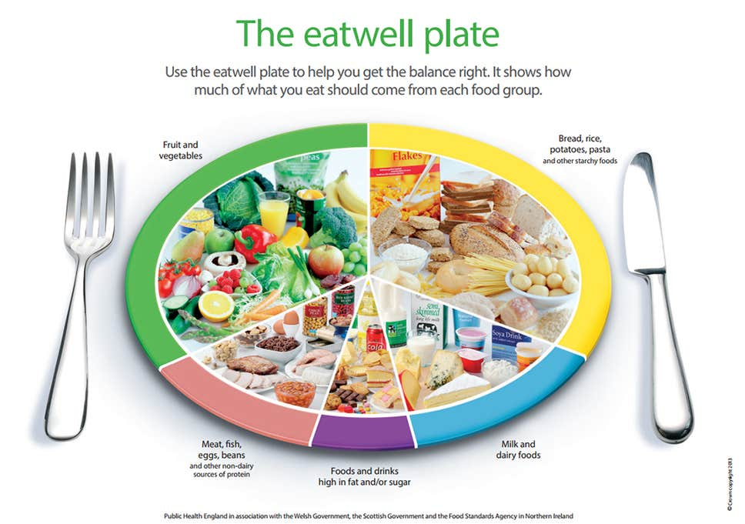 |  |  | adult a person who is fully developed or grown.  baby a very young child.  backbone the column of small linked bones down the middle of your back.  balanced diet a variety of food that you regularly eat.  basic needs the minimum required to satisfy needs / the important needs for life.  bones the hard parts inside your body which form your skeleton.  calcium a mineral that is necessary for life. It helps to build bones and keep them healthy, enables blood to clot, muscles to contract and our heart to beat.  disease an illness which affects people, animals or plants.  elderly an old or ageing person.  essential absolutely necessary, extremely important.  exercise when you exercise, you move your body energetically in order to get fit and to remain healthy.  healthy well and not suffering from any illness.  illness a period of sickness affecting the body or mind.  infant a young child.  life cycle the series of changes that an animal or plant passes through from the beginning of its life until its death.  minerals inorganic nutrients in foods that are essential for growth and health and do not contain carbon.  muscles something inside your body which connects two bones and which you use when you make a movement.  nutrients a substance that provides nourishment essential to life and growth.  offspring a person’s children or an animal’s young.  option a thing that is chosen, a choice.  shelter a place giving protection from bad weather or danger.  skeleton the framework of bones in your body.  standards a level of quality.  substitute use or add in place of.  survive continue to exist.  teenager a person aged between 13 and 19 years old.  toddler a young child who is just beginning to walk.  vitamins a group of organic compounds required by the body in small amounts to enable normal growth and health.  wants to desire to possess or do; to wish for.
What will I know by the end of the unit?
Can I describe how animals change as they grow?
Can I describe how humans change as they grow?
Can I describe the basic needs of humans and animals?
Can I explain why it is important that humans exercise?
Can I explain how and why should we keep ourselves clean?
Can I identify healthy and unhealthy food and say how much of them I should eat?
Can I plan and carry out an investigation (into whether older children are always faster?)
Can I observe closely and describe what I see.
Can I draw conclusions based on what I know?

