William Barnes Primary – Geography
Topic: Australia |  |  | Strand: Location Knowledge &  Human and Physical Geography | Year 2
What should I already know? |  | Geographical Skills |  |  |  | Vocabulary
- Developing knowledge of human and physical geography of local area  - Some correct geographical vocabulary to refer to key features  - Locate the UK and polar regions on world maps, atlases and globes  - How to use simple compass directions  - How to devise a simple map with basic symbols in a key  - Be able to name and locate the world’s seven continents and five oceans  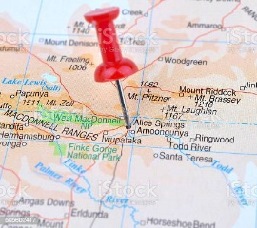  - Identify hot and cold areas of the world |  | Can I ask and answer geographical questions (such as: What is this place like? What or who will I see in this place? What do people do in this place?  Can I use world maps, atlases and globes to locate the United Kingdom and its countries and Australia? Where is Australia? Can I plan a route to Australia using a world map?  Can I recognise key human and physical features of Australia and compare to the UK?  Can I recognise human and physical features and landmarks around Sturminster Newton and Alice Springs using aerial photographs and Google Earth?  Can I use locational and directional language to describe the location of Sturminster Newton and Alice Springs on a map? |  |  |  | Locational Knowledge:  Earth, globe, continent, country, ocean  Asia, Africa, Europe, North America, South America, Australia, Antarctica, Arctic, Atlantic, Pacific, Indian, Southern (ocean) North Sea  Place knowledge:  London, Canberra Sydney,, Sturminster Newton, Alice Springs, Local, climate, tourism, forage,  Human and Physical Geography:  Rainforest, Desert/Outback, Coast, Urban, river, habitat, weather, mountains, hills, vegetation, island  Geographical Skills and Fieldwork:  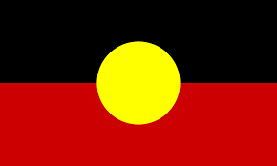  Map, atlas, globe, key, aerial, route, landmark, physical features, human features  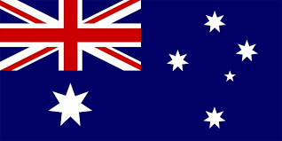
 |  | Geographical Knowledge
Can I describe the landscape features of some areas of Australia using Aerial photographs and Google Earth?
Can I name the seven continents and the seas/oceans around the UK and Australia?
Can I explain why Australia has two flags?
Can I explain than human features are made by man and physical features are created by nature?
Can I explain why and how people might choose to live in different habitats around Australia? (desert, coastal, rainforest, urban)
Can I explain how to the climate in Sturminster Newton compares to Alice Springs?
Can I name some foraged food found in our local area compared to the area around Alice Springs/The Outback?
Can I explain some geographical similarities and differences through studying the human and physical geography of different habitats in Australia and Alice Springs (a place in a non-European country)
Additional Learning Opportunities
Australia WOW day
Making traditional instruments
Aboriginal art – printing and clay work

