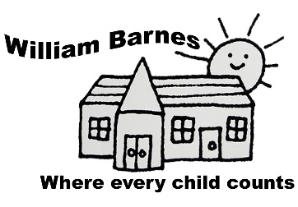
William Barnes Primary School
Bridge Street
Sturminster Newton
Dorset DT10 1BZ

Tel/Fax: 01258 472257
E: office@williambarnes.dorset.sch.uk
W: www.williambarnes.dorset.sch.uk
Dear Parents and Carers,

Many thanks to all the families who chose their pledge to #Do1Thing last term, in support of our school focus on United Nations Sustainable Development Goal 12: Reduce, Reuse, Recycle. It is wonderful that we can teach our children how to live in a more sustainable way which will impact the quality of life on earth for generations to come. Our Eco-Warriors group have now had a number of sessions and Year 4 have been enjoying the Forest School learning every week this half term.

This term we are focusing on Sustainable Development Goal 3: Good Health and Well-being. There has been a great deal in the press in recent months about the mental health of us all and children in particular. These have certainly been tough times for everyone. As a school we have already put a number of systems in place to support positive mental wellbeing for pupils and staff including Calming Time in our Jigsaw PSHE lessons; a newly appointed Mental Health Champion (Mrs Lewis); Worry Boxes in every classroom and we have signed up to the DfE Wellbeing Charter. William Barnes is also an Attachment Friendly School and all staff are trained in Attachment and Emotion Coaching.

In addition, we are going to do the following actions this term to support our Global Learning in this area:
- Take part in Children’s Mental Health Week 2022 and use some of the resources with each class. https://www.childrensmentalhealthweek.org.uk
- Use a set of beautiful, new books from the local library that cover issues that affect many of our children (such as talking about worries, ways to reduce anxiety etc) and use in classes during story time as appropriate.
- Support the wonderful https://www.thekidsareallbike.com/ initiative run by our School Governor Mr Sweetenham.
- Year 2 Visit to Wessex Water to learn about water conservation and recycling and water availability in different parts of the world.
- Mindfulness Day
- Collection for the Vale Pantry Food Bank and for Save the Children Afghanistan appeal as part of our Global Learning about issues around food poverty locally, nationally and globally. (TBC)
- Year 6 will also have their annual fundraising event for the Malala Foundation – supporting access to Education for girls
If any parents have any great ideas they would like to share to support our learning in this area this term, please do contact Mrs Wrixon or Mrs Gilham on year2@williambarnes.dorset.sch.uk.
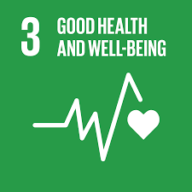
Many thanks as always for your ongoing support,

The William Barnes Staff

