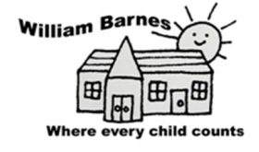
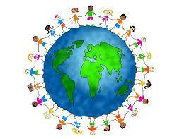
Global Learning School Plan 2022-2023
Autumn Term  Lead Staff Member: Mrs Gilham | Spring Term  Lead Staff Member: Mrs Wrixon/Mrs Lewis | Summer term  Lead Staff Member: Mr Field
Goal 12:  Ensure sustainable consumption and production patterns | Goal 3:  Good Health and Wellbeing. Ensure healthy lives and promote well-being for all at all ages. | Goal 15:  Life on Land. Sustainably manage forests, combat desertification, halt and reverse land degradation, halt biodiversity loss.
Jigsaw  Being Me in My World  Celebrating  Difference | Jigsaw  Dreams and Goals  Healthy Me | Jigsaw  Relationships  Changing Me
Connected Curriculum Topics  Y1: Me and My World  Y2- Australia  Y3- India  Y6- Our Earth, Key Focus: Global Goals, Malala Day | Connected Curriculum Topics  Y1- DT: Healthy Eating  Y2 – Trip to Wessex Water: Water conservation/water filtering  Y3- Animals including Humans, Music: Human Body  Y4 – DT: Seasonal/local produce, Cooking balanced meals  Y5 – Mountains, Nutrition and Cooking, Music: Keeping Healthy  Y6- Animals Including Humans | Connected Curriculum Topics  R – Minibeasts  Y2 – Animals Including Humans  Y3 - Rainforests (incl. Endangered Animals)  Y4 - Living Things and their Habitats  Y5 – Animals Including Humans  Y6 - Living Things and their Habitats, Born Free Foundation, History of Animal Welfare, Protest
Assemblies  SDG launch assembly (LG)  Reduce, Reuse, Recycle, Recover (LG)  Armistice Day (KW) | Assemblies  Fairtrade fortnight (LG)  World Book Day (RF)  World Water Day (LG) | Assemblies  Born Free Foundation (RF)  World Environment Day/World Oceans Day (LG/KW)
Fundraising Events  Children in Need  Malala Day – Rights of the Child | Fundraising Events  Red Nose Day  Daffodil Appeal Marie Curie | Fundraising Events  Born Free Foundation Fundraiser
Global Events Calendar  World Ozone Day  Black History Month - October  UN One World Week  Armistice Day | Global Events Calendar  Fairtrade fortnight  World Book Day  International Day of Happiness  World Water Day or Oxfam Water Week | Global Events Calendar  World Environment Day  World Oceans Day

