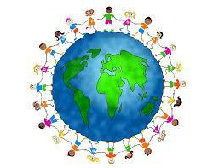
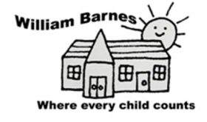
Subject Development Plan: Global Learning 2022-20223
Key Issue: Develop Global Learning within the taught school curriculum, embed school commitments to SDG’s
SDG= United Nations Sustainable Development goals.
*carried over from previous action plan due to covid disruption
Objective | Planned Impact | Process | Who and When | Resources | Monitoring | Review | Next Steps
To make a link with an international school using British Council Connecting Classrooms or similar  *must be done again as Nepal school closed link due to covid difficulties | Contributes to coverage of Global Learning objectives. Pupils gain an understanding of another culture, life beyond the UK and how we are connected to others and to work collaboratively with another school on Global Issues. | Use British Council and connecting classrooms website to match with a global school. Begin communication, organise connecting pupils and complete a collaborative project | LG 2021-2022  *timescale will depend on global covid restrictions | NA | KW
To support SDG learning with visitors to the school | Support understanding and promote purpose of each SDG and inspire pupils to contribute | One visitor per term booked that aligns with the termly SDG | LG | Assembly time | KW
To create a Global Learning display | To promote and raise awareness of the work of the school | In the hall | LG and RF by end Autumn 2 | time | RF
To add Global Learning objectives to long term planning  *Carried from school closure period | To ensure coverage and progression across the school | Select GL objectives to enhance existing taught curriculum. | All teaching staff at staff meeting Spring term | Oxfam curriculum map for Global Learning objectives  Staff meeting time | LG
To work with School Council in leading the SDG agenda in school | Pupil voice is used to agree agenda for change within school to support our SDG agenda | LG meet with school council | LG fortnightly | LG time during assembly

