William Barnes Primary School
Bridge Street
Sturminster Newton
Dorset DT10 1BZ

Tel/Fax: 01258 472257
E: office@williambarnes.dorset.sch.uk
W: www.williambarnes.dorset.sch.uk

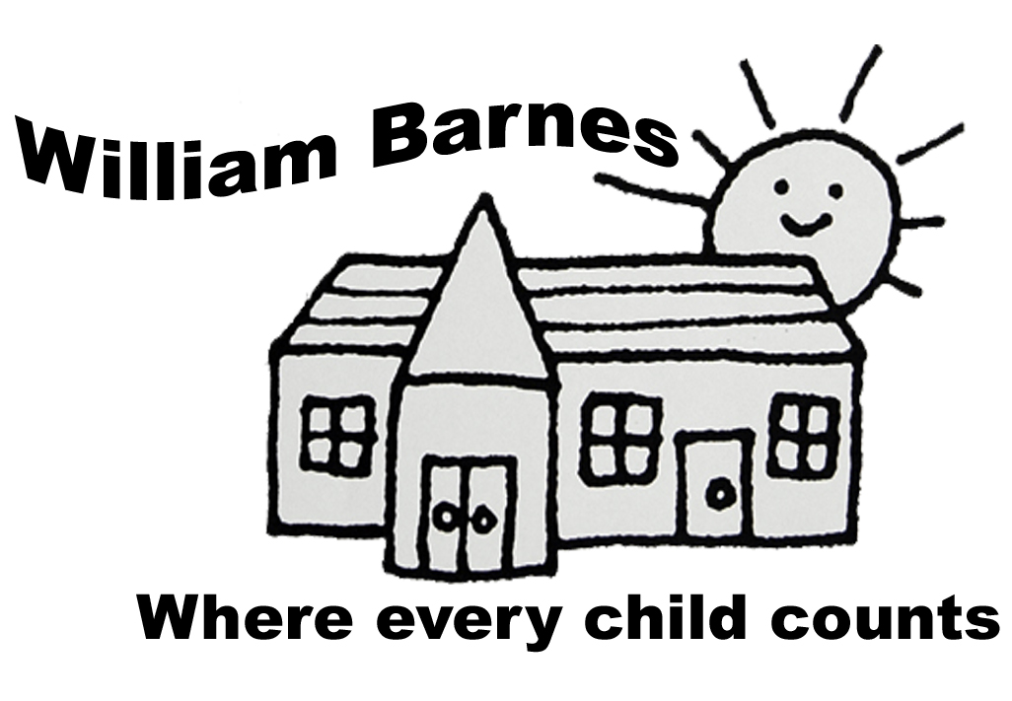

Dear Parents,

As you may know, last year we were awarded the International School Award – Foundation level for developing Global Learning in our school.

We are trying to embed aspects of Global Learning and Citizenship in to our everyday classroom teaching and have a whole school focus on three of the United Nations Sustainable Development Goals; SD3 Good Health and Wellbeing, SDG 12 Responsible Consumption and Production and SDG15 Life on Land which has led to a number of projects that are currently running or planned for in school like our work on reducing plastic waste and the Terracycle project.

This term we are focusing on SDG 12 and are looking at ways in school to Reduce, Reuse and Recycle, with the driving force coming from our Eco-Warrior pupils across the school. As the world is watching the current COP26 Climate Action conference in Glasgow, each class has decided to make a pledge this term to #Do1Thing to contribute towards the local, national and global efforts towards reducing the human impact on the climate. Some of these actions include reducing paper waste, turning lights and projectors off when not in use and reducing laminating.

Many of our children feel passionate about Climate Action and so we are inviting our families to also make a pledge to #Do1Thing. The idea is to choose one small thing that your family can try and do to contribute to the global effort and we would love as may families as possible to take part.
We have attached some ideas to get you started but you may already be doing something or have another brilliant idea. Please complete and send pledge form (on reverse) back to school so the children can start to see how if we all make small changes, the impact can add up and we can celebrate our efforts together.

Many thanks for your support,

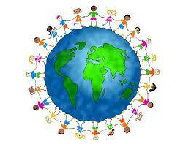
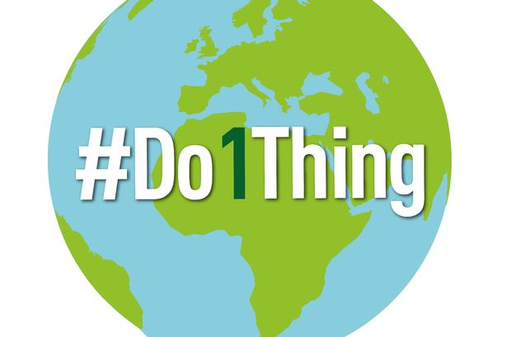
The William Barnes Staff.

Simple ideas to Reduce, Reuse, Recycle at home:
- Save electricity by plugging appliances into a power strip and turning them off completely when not in use.
- Turn off the lights.
- Air dry. Let your hair and clothes dry naturally instead of running a machine. If you do wash your clothes, make sure the load is full.
- Swap some baths for shorter showers
- Eat less meat each week (particularly beef)
- Use your food compost bin.
- Recycle everything into the correct bin.
- Try and buy some food with less packaging.
- Shop local.
- Use a refillable water bottle and coffee cup and drink tap water when you can
- Donate what you don’t use rather than throwing it away or turn it into something new
- Avoid wasting food – plan meals before you shop
- Try and walk or cycle to school or your local area more than you do now
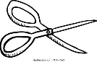
- Speak up! Ask your local and national authorities to engage in initiatives that don’t harm people or the planet. Share what you are doing with family and friends
--------------------------------------------------------
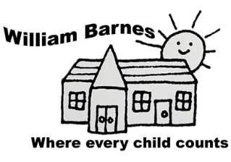
#Do1Thing

To help support Sustainable Development Goal 12: Reduce, Reuse, Recycle.
The _________________________ family

Pledge to
____________________________

____________________________

