Visual Methods | Mental methods | Written methods
Addition  Children will begin by counting objects by touch.  A range of visual methods will be taught supported by equipment (counters, shells, bottle tops, counting bears, unifix cubes, counting animals and insects, pegs). For example:  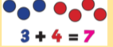  Regular use of a ten frame to secure understanding of numbers 1-10 first and then up to 20.  Children will be able to place number cards to say this image shows 3 + 4 = 7. Children will be encouraged to start at 3 and count on, rather than counting each number individually. Extending to: Understanding of the equals sign is important.  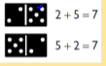  It is important that children understand that addition can be done in any order and that putting the biggest number first is the most efficient method. | Addition  Use of games, songs and practical activities will help children to begin using vocabulary. Children will be taught to put the biggest number in their head and count on.  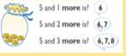  Real life examples such as putting coins in a tin so children can hear them drop or adding biscuits to a plate will help to aid understanding through counting on.  They will use this knowledge to be able to say 1 more than a given number. They will solve simple word problems using their fingers.  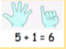  Use of a number line or number track will support counting on through making jumps on a number line starting from the biggest number.  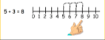 | Addition  Children will record addition statements as pictures.  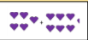  This will be extended to writing a number sentence e.g. 3 + 2 = 5.  Children will be able to record their working out on a ten frame when given addition statements.  Given: 3 + 4 =  Child draws:  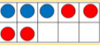and calculates as 7.  Real life contexts using ten frames will also be taught e.g. money using 1p coins.  Ten frames can be used for solving problems linked to current topic e.g. 3 spacemen fly to the moon on Monday. Another 4 fly on Tuesday. How many spacemen are there altogether?  