William Barnes Primary School
Unit: Mountains and the Impact of Tourism | Year 5

What should I already know? |  | Diagrams and Maps
- The United Kingdom is comprised of England Scotland Wales and Northern Ireland  - The capital cities of the four countries of the UK  - How to locate the four countries of the UK on the map  - How to locate where I live on a map of the UK  - Some of the features of each of the four countries of the UK  - Names of different Geographical features, hill, valley, coast, forest, shore, cliff, mountain, river, lake, urban rural  - the difference between physical and human geography  - Name examples of physical and human geography in the UK  - Recognise symbols on an OS map  - The names of some areas of higher ground in the UK including the Pennines, Grampian Mountains and Sperrin Mountains  - Name and identify on a map the seven continents and some of the countries in each continent  - Name and identify on a map the five oceans  - Identify the equator, lines of latitude and the Northern and Southern hemispheres |  | 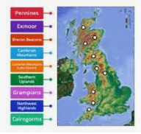  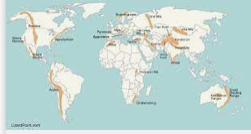
Geographical Skills |  | What should I know by the end of the Unit?
Map Skills  Use maps and atlases, including computer mapping.  Physical Geography  Human geography | - Locate UK mountain ranges and hills Bodmin Moor, Dartmoor, Exmoor, The Pennines (Peak District, Dales and Lakes), the Yorkshire Moors, The Scottish Highlands, Wicklow Mountains, Snowdonia, Brecon Beacons  - Identify highest mountains in England, Wales and Scotland Scafell Pike, Snowdon and Ben Nevis respectively  - Locate the Mountain Ranges of the World include Rockies, Appalachians, Andes, Alps, Pyrenees, Himalayas, Australian Alps, Ethiopian Highlands, Atlas Mountains  - Identify Everest as the highest mountain in the world and is in Nepal  - Describe the height and slop from a map  - Read and compare map scales  - Use 4 and 6 figure grid references to find places on a map  - Describe the key features of a mountain  - Describe the weather associated with mountains  - Compare mountains in the UK and Ladakh in the Himalayas including weather noting similarities and differences  - Investigate and compare settlements and land use in the Lake District and Ladakh  - Investigate and evaluate the impact of tourism on Ladakh | - The mountains and mountain ranges of Great Britain and the world.  - The key features of a mountain  - What a rain shadow is and how it affects the weather on each side of a mountain or mountain range  - Ladakh in northern India has a traditional culture unchanged before 1974  - Tourism can have positive and negative effects  - That small causes can lead to very large effects  That to help Ladakh culture to survive tourists need to help the Ladakhi people.

William Barnes Primary School
Unit: Mountains and the Impact of Tourism |  | Year 5
Vocabulary
- Mountain Range – number of mountains grouped together in a single region
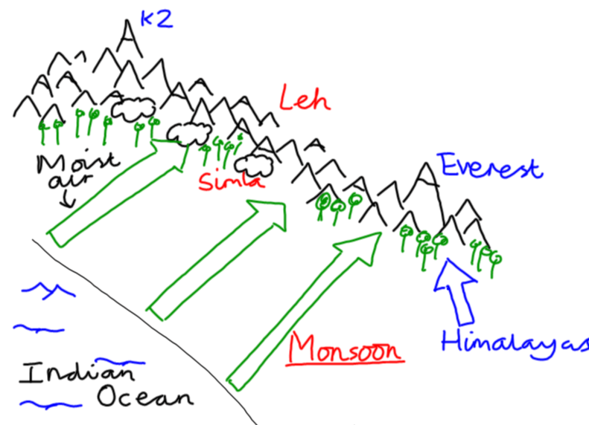
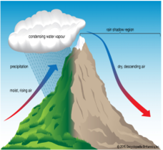
- Summit – top of the mountain
- Snow line – above here snow and ice cover a mountain all year
- Outcrop – rock formation visible from the surface
- Slope – area of ground increasing in height
- Plateau – area of flat high ground
- Valley - area of low land between mountains
- Rain shadow – where a mountain range blocks rain from falling
- Monsoon - a seasonal shift in wind direction. It can cause heavy rainfall during the summer and dry spells in the winter.
- Culture – shared ideas and customs of a group of people including food, entertainment, religion, clothing and housing
- Tourism – people travelling for enjoyment
- Tourist – a person who travels for enjoyment

Key Facts Ladakh
Physical Geography | Traditional Ladakhi Culture | Changes since Tourism | Reducing Impact of Tourism
- Ladakh is a mountainous region in northern India which is completely cut off by snow for six months each year  - The weather in the Lake District is wet because of the rain shadow  - Ladakh is a high altitude desert because of the rain shadow  - Ladakh was completely cut off from the modern world until 1974 when tourism began | Ladakh has an ‘old traditional’ culture that has been unchanged for 1000 years  - Buddhism and Islam peacefully coexist although the region is predominantly Buddhist  - Peaceful culture based on non-harming and looking after the environment  - Everyone has a large house with several acres of land  - Water is shared between households  - Many generations live together in the same house  - There is no money, everything is shared or bartered for  - Apricots, barley, tsampa (water and flour), butter tea, chang (barley beer), yak’s cheese are staples  - Poor health care and high infant mortality  - Nu unemployment or homelessness and little or no stress  - Many festivals throughout the year  - Strong sense of community  - Women make all the decisions in the home | - Homelessness  - Pollution from flush toilets and detergents in rivers and exhausts from vehicles  - Water shortages  - Young people leaving farms for a modern life in city  - No longer enough people to keep the farms running  - Loss of confidence amongst Ladakhi people  - Increased disease  - Children forced to go to school but taught in a different language | - Tourists wear suitable clothes  - Do not take pictures of Ladakhis without permission  - Are careful not to spend too much money  - Attend events that celebrate Ladakhi culture  - Hep by volunteering to work on a farm  Do not visit Ladakh
Additional learning experiences and activities | Mindfulness in the Mountains day – whole day exploring Ladakhi culture through drama, stories, cooking (dahl and flatbreads), and making mala bead necklaces, katak scarves and mani stones

