William Barnes Primary School |  | Subject: Science
Unit: Earth In Space |  | Year 5
What should I already Know?
- That the light from the Sun can be harmful to our eyes and skin.
- That a shadow occurs when light from a source is block.
- Light travels from a light source and travels into our eyes and this how we see.
Scientific Learning
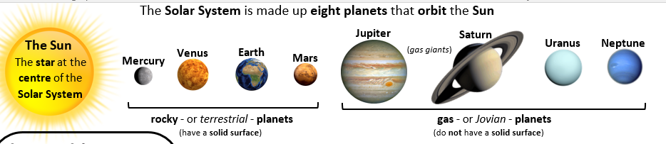
My Very Easy Method Just Speeds Up Naming Planets can be used to memorise the planet names. Pluto is no longer considered to be a planet – it is now called a dwarf planet.
The Earth, the Sun, the Moon and all the planets are spherical in shape.
It used to be believed that the Earth was at the centre of the Solar System (Geocentric model). The idea that the Sun was the centre of the Solar system (Heliocentric model) was not widely believed until the 17th century. This was due to the thinking of Copernicus, Galileo and Kepler.
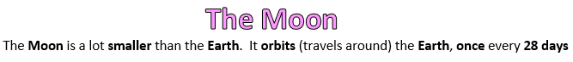
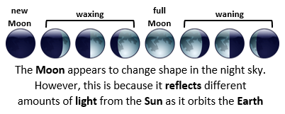 |  |  | 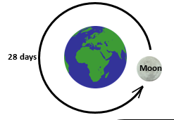
What should I Know by the end of the unit?
- The names of the planets in order and which planets are rocky and which are gaseous giants.
- Three reasons to explain why the Earth is not flat.
- The difference between the Geocentric and Heliocentric models and the role of Galileo in developing the Heliocentric model.
- The Earth orbits the Sun every 365.25 days and this is one year.
- The Moon orbits the Earth every 28 days and what the phases of the Moon are.
- The night and day are caused by the Earth spinning anticlockwise on its axis every 24 hours.
- That the Seasons are caused by the tilt of the Earth on its axis as it orbits the Sun.
- The Moon can be visible during the day.
- The Earth is divided into twenty four time zones.
Vocabulary
Planet  Star  Gravity  Orbit  Solar System  Astronomy  Sphere  The Sun  Moon  Geocentric  Heliocentric | An object that orbits a star and is not a primary light source.  A giant ball of gas held together by its own gravity that makes heat and light energy.  The force that attracts an object towards a larger object.  A curved path of planet taken one body around another.  The Solar System consists of the Sun and everything that orbits the Sun.  Astronomy is the study of outer space often using telescopes.  A round 3d shape like a ball.  Is the star at the centre of the Solar System  A large spherical rock that orbits a planet.  The Geocentric model has the Earth at the centre of the Solar System.  The Heliocentric model has the Sun at the centre of the Solar System.

