÷ | William Barnes Primary School Written calculation Policy 2016
Year | Calculation | Numicon reference or calculation name | Progression in recording written calculations |  |  |  |  |  |  |  | Notes
 | 10÷2=5  8÷2=4 | Kit 2 Calc.19  The sharing nature of division  Kit 3. Calc 11 | 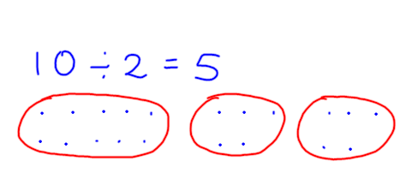 | 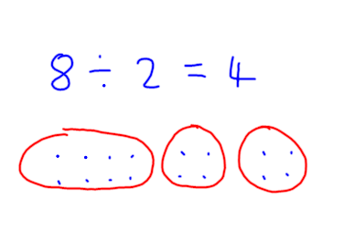 |  |  |  | Don’t record with number lines when sharing.  Say “Divide 10 into two equal parts.”  Say “Divide 15 into 3 equal parts.”  Sharing inefficient when group sizes and numbers increase e.g 64÷4
2 | 15÷3=5  22÷4=5R2 | Kit 2 Calc.20  Kit 3 Calc.11 | 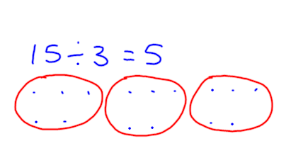 | 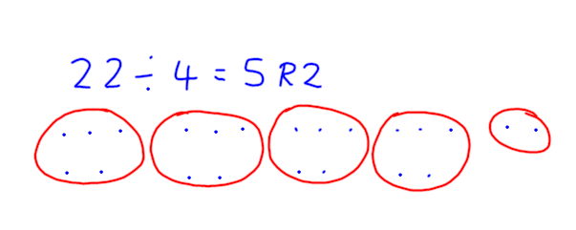 |  |  |  | Once children understand sharing, focus on counting up or repeated addition e.g “How many 4s in 44?” Once children secure with number line move onto short multiplication.
2 | 50÷10=5  20÷5=4  12÷4=3 | Kit 2 Calc.17  Counting up strategy  Kit 3 Calc. 7 | 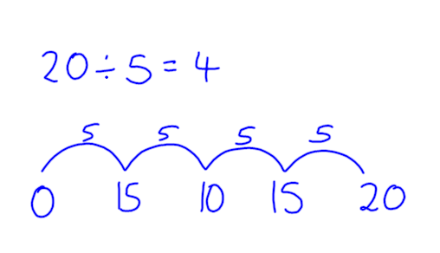 |  |  |  | 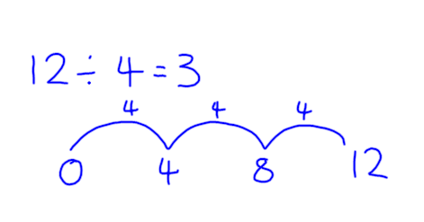 |  |  | Say “How many 10s in 50?”  Number lines for less able – support with apparatus
2 | 32÷5=6R2  17÷3=5R2 | Kit 2 Calc.18  Counting up strategy  Kit 3 Calc.7 | 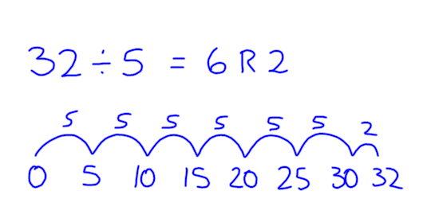 |  |  |  | 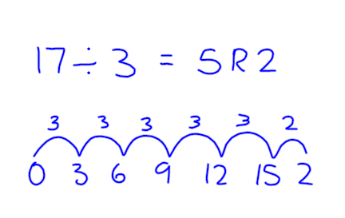 |  |  | Say “How many 5s in 32?” Make sure practical work is recorded with number lines
3 | 44÷4=11 |  | 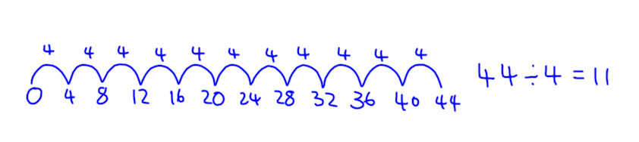 |  |  | 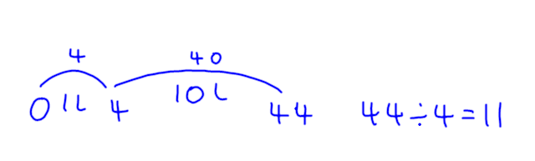 |  |  | Record using number lines – repeated subtraction
4 | 90÷8=11r2 |  | 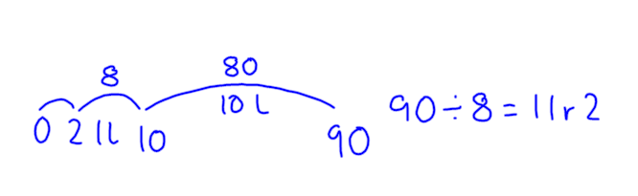 |  |  |  |  |  | Repeated subtraction on number line – first step for chunking
4 | 42÷3=14  185÷5=37 |  | 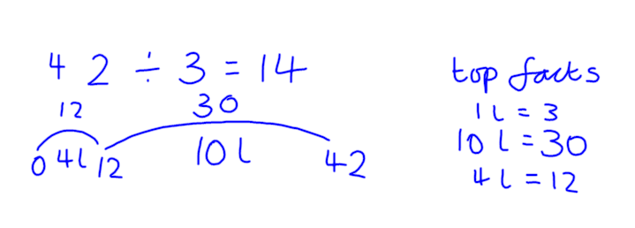 |  | 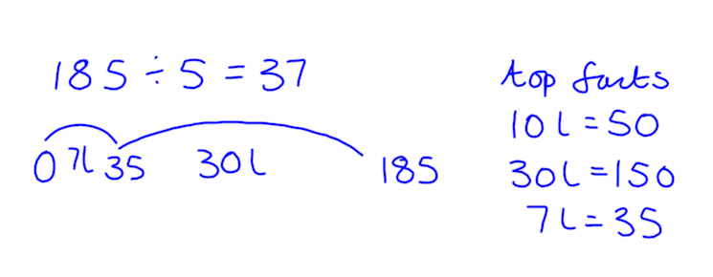 |  |  |  | Moving to larger chunks Write down “top facts”at the start . Record as l for “lots” to avoid using the multiplication sign.
5 | 224÷7=32  356÷6=59r2 |  | 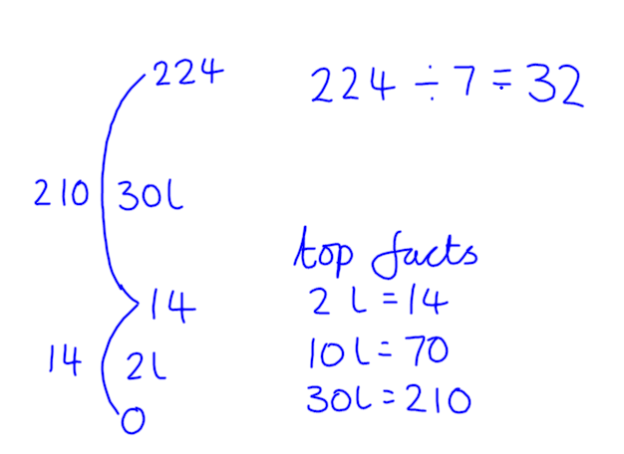 |  | 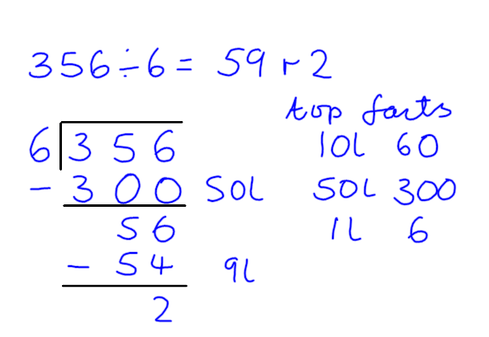 |  |  |  | Move to vertical number line then begin recording as column method. This is preparation for dividing by 2 digit numbers.
5 | 84÷4=21  165÷5=33 |  | 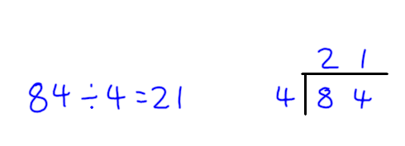 |  | 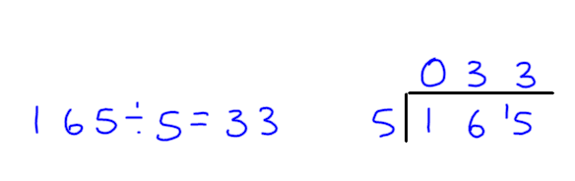 |  |  |  | Short division or “bus stop” method.  Use when dividing by single digit
5 | 226÷7=32.285  3444÷8=430.5 |  | 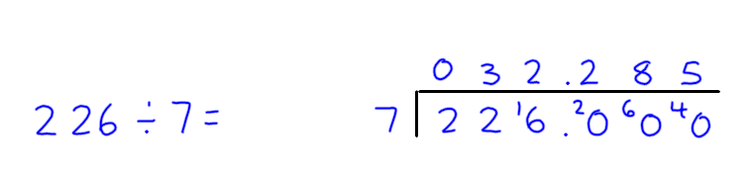 |  | 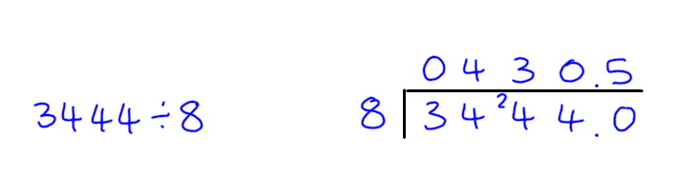 |  |  |  | Useful when dealing with remainders.
5 | 295.4÷7=42.2  183÷9=20.333 |  | 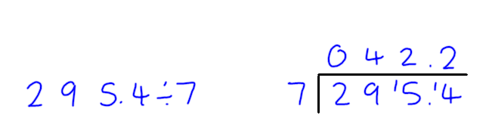 |  | 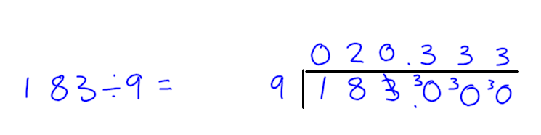 |  |  |  | Useful for exploring recurring decimals.
6 | 390÷32=12r6  9152÷22=416 |  | 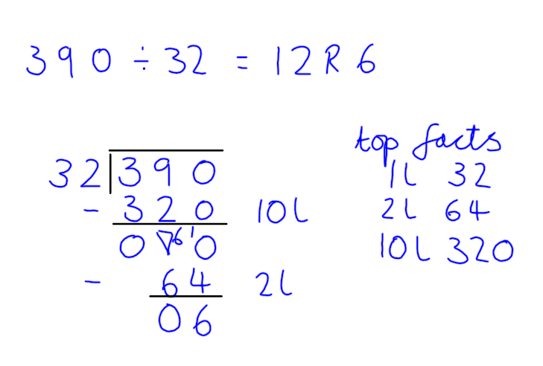 |  | 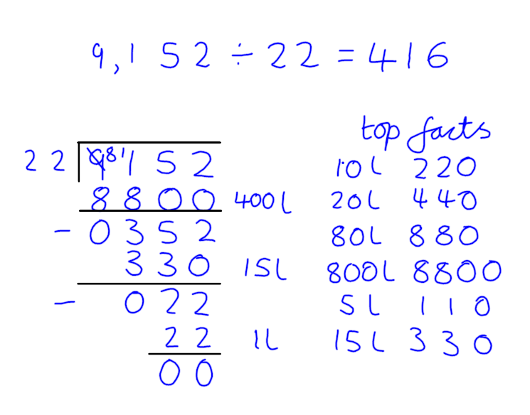 |  |  |  | Use chunking method when dividing by a 2 digit number.

