- | William Barnes Primary School Written Calculation Policy 2016  Subtraction
Year | Calculation | Numicon reference or calculation name
R | 3=3, 4=4 | Kit 1 Calc 2B | Establish that = means “the same as” not “give me the answer” |  |  |  |  |  | Meaning of =
R | 10 -2 | Firm Foundations 12A |  |  |  |  |  |  | Children take away by hiding holes.
R | 8-1, 7-1 | Firm Foundations 12B
R | 4-3, 3-1 | Firm Foundations  13A, 13B
1 | 8-2, 7-3 | Kit 1 Calc 3A | 8 take away 2 equals 6 8 – 2 = 6  7 subtract 3 equals 4 7 – 3 = 4 |  |  |  |  |  | Use words first then introduce symbols
1 | 7-2, 4-2 | Kit 1 Calc 4B | 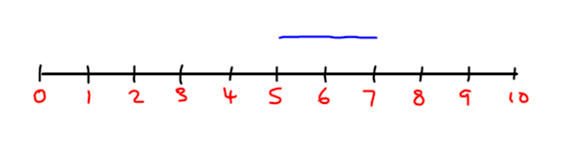 |  | 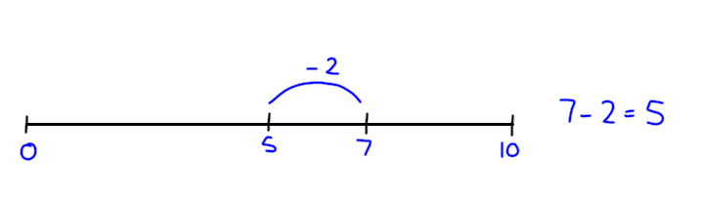 |  |  |  | At first give the children ready made number lines
1 | 7-0 | Kit 1 Calc 6B | 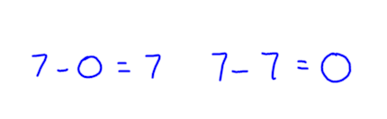 |  |  |  |  |  | Role of zero in subtraction
1 | Difference between 8 and 6 or 6 and 8  8-6=2 | Kit 1 Calc 7A | 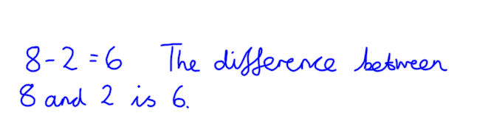 |  |  |  |  |  | Introducing the idea of difference early
1 | 10-1, 10-2, 10-3, 10-4,  10-5 | Kit 1 Calc 7B  Complement to 10 | 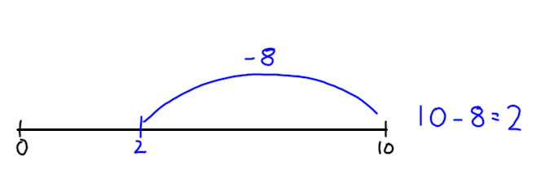 |  |  |  |  |  | Children need to memorise complements to 10 as part of the 55 club
1 | 30-3  60-5  40-8 | Kit 1 Calc 12B | 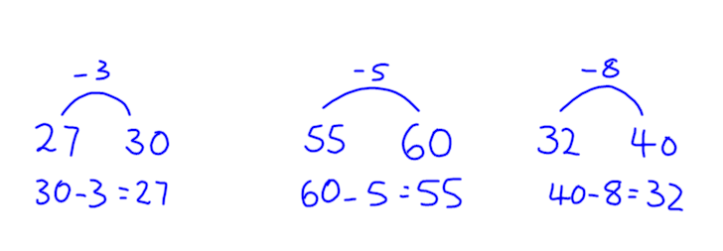 |  |  |  |  |  | Preparation for bridging 10  Children drawing their own number line jottings
1 | 15-7  13-6 | Kit 1 Calc 13B  Bridging 10 | 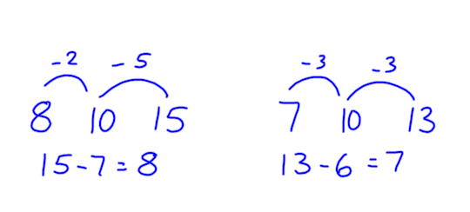 |  |  |  |  |  | Bridging 10 – children apply their knowledge of number bonds learnt through the 55 club. Numbers less than 20.
2 | 23-5  75-8  93-6 | Kit 2 Calc 8  Bridging 10 | 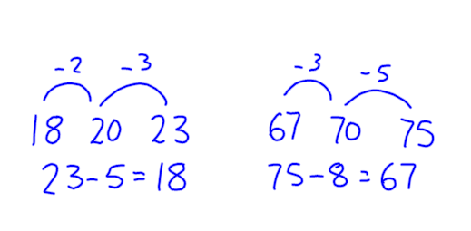 |  |  |  |  |  | Bridging 10 – numbers less than 100.
2 | What is the difference between 57 and 65?  65 - 57 | Kit 2 Calc 8  Difference | 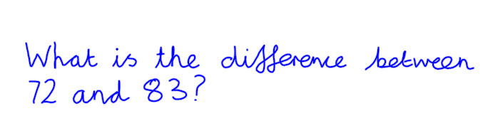 |  |  | 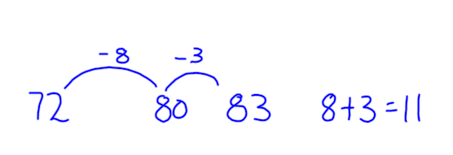 |  |  | Revisit concept of difference with large numbers and bridging using counting back
2 | 43-28  62-34  96-38 | Subtraction using number lines | 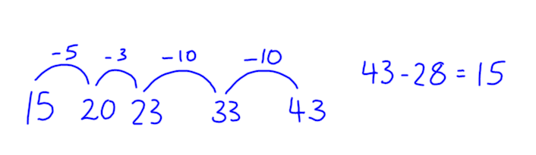 |  |  | 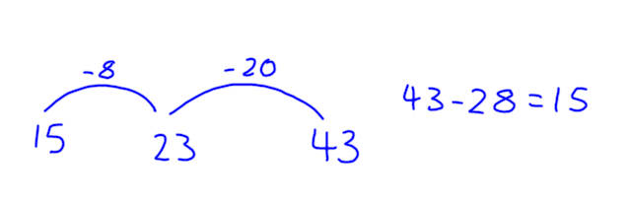 |  |  | Subtraction by counting back along the number line, in 10s then by multiples of 10
3 | 43-28  128-136  984-765  984-795 |  | 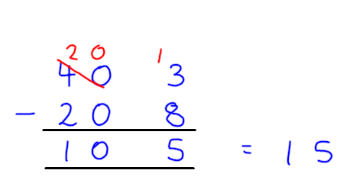 | 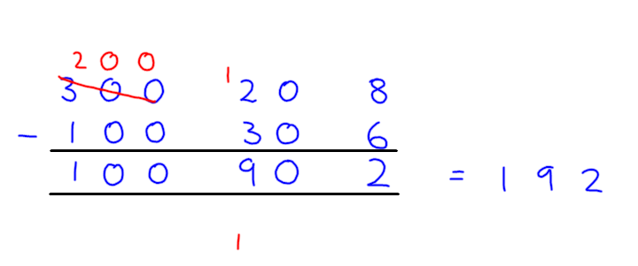 |  |  |  | 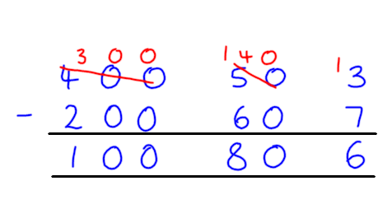 | Develop expanded method to 3 digits. Dienes can be very useful for concrete work. (Numicon pieces take up too much space)
3 | 128-136  984-765  984-795 |  | 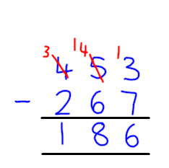 |  |  |  |  |  | Start with one column requiring “borrowing”, then extend to two columns requiring “borrowing”.
4 | 6534-6537 |  | 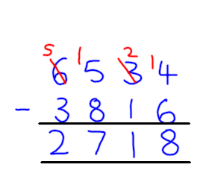 |  |  |  |  |  | “Starting with the units, the 4 isn’t large enough to subtract six. We make it bigger by borrowing 10 from the tens column. The four becomes 14, whilst the thirty becomes twenty.”
5 | 73,826-24,738  532,413-243,724  216.3-7.36 |  | 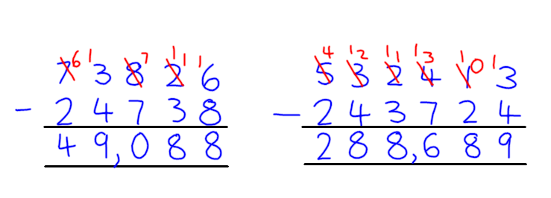 |  |  |  | 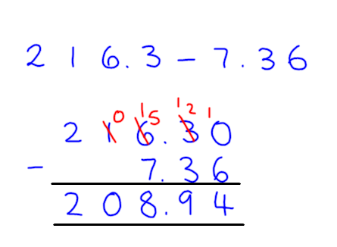 |  | Children are fluent in their number bonds and are not troubled by the complexity of these calculations working fluently and with pace.
6 |  |  | No new content in Year 6 for subtraction

x | William Barnes Primary School Written Calculation Policy 2016  Multiplication
Year | Calculation | Numicon reference or calculation name | Progression in recording written calculations |  |  |  |  |  |  | Notes
R | Counting  1-10 in 1s  0-20 in 2s  0-100 in 10s  0-20 in 5s | No reference in Firm Foundations | 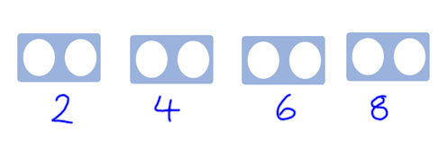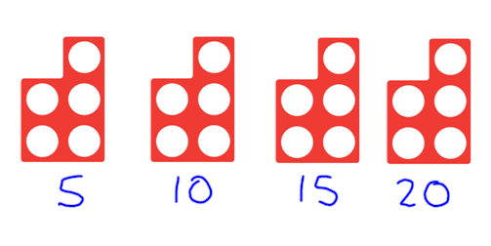 |  |  |  |  |  |  | Use objects as well as Numicon tiles
1 | Counting in groups of 10  10,20,30 etc. | Kit 1 NANS 3B | 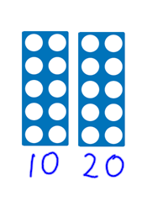 |  | 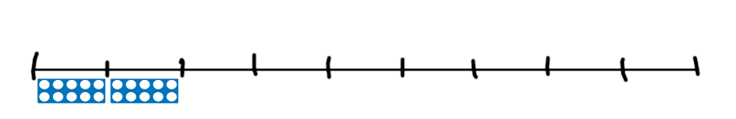 |  |  |  |  | No recording at this point
1 | Extend number sequences | Kit 1 Pattern 5B |  |  |  |  |  |  |  | Also see Kit 1 NANS 5  Kit 2 Pattern 7 for relevant experience
2 | 4x2, 3x5  4x3, 2x7 | Kit 2 Calc 12 | 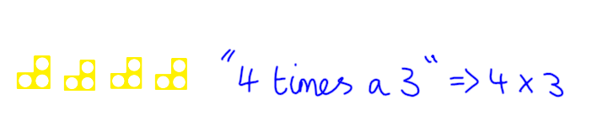 |  |  |  |  |  |  | Kit 2 Calculation 11 – practical introduction – no recording
2 | 3+3+3+3+3 5x3  10+10+10  3 x 10 | Kit 2 Calc 13 | 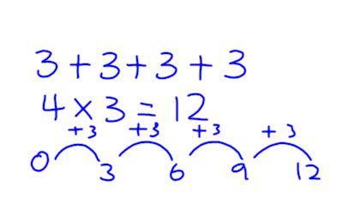 |  |  | 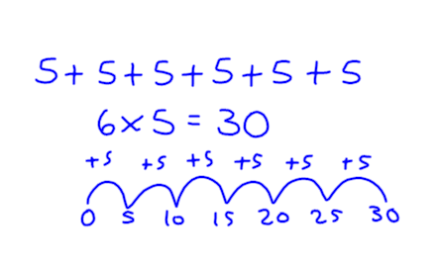 |  |  |  | Use number tracks and rods – then use number line jottings
2 | 3 x 4 = 4 x 3 | Kit 2 Calc 14 | 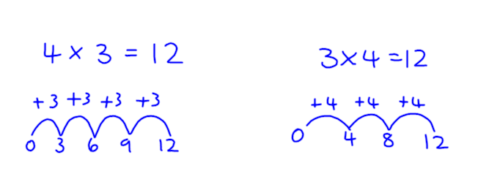 |  |  |  |  | Kit 2 Calc 15 focusses on doubles and multiplying by 1 |  | Although Numicon does not use these, record with number ines
2 | 3,4,5 times table | Kit 2 Calc 16 | 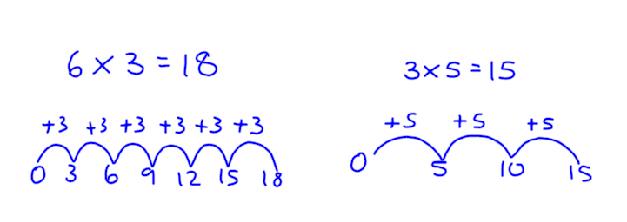 |  |  |  |  |  |  | Use number lines to record practical work.
2 | 12 x 5  14 x 3 | Final numberline stage | 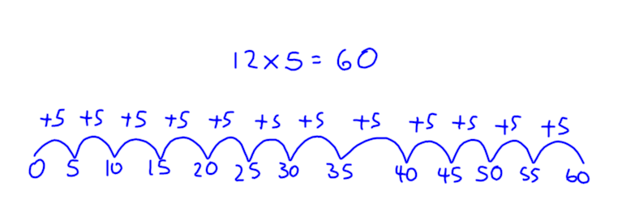 |  |  |  |  |  |  | Number lines reaching their limit and becoming too cumbersome.
3 | 5 x 14  4 x 32 | Short multiplication expanded | 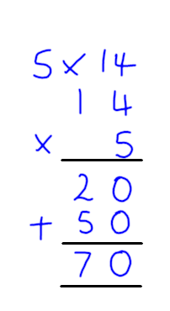 | 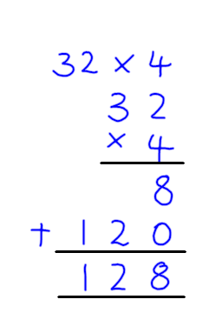 |  |  |  |  |  | Introduce column multiplication with an expanded method.  The addition part should be completed mentally starting with the largest number.
3 | 5 x 63 | Short multiplication | 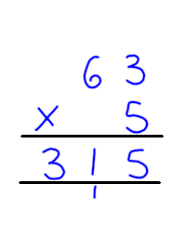 | 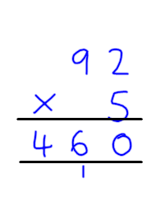 |  |  |  |  |  | Children record carrying. Please write carries under the answer box
4 | 8 x 73  7 x 364 | Short multiplication | 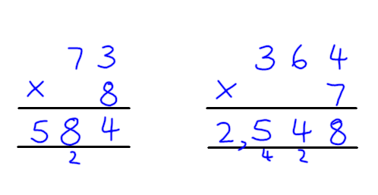 |  |  |  |  |  |  | Extending method to hundreds and including all times tables.
5 | 6 x 5237  20 x 623  60 x 5783  37 x 54  57 x 2653 | Short and long multiplication | 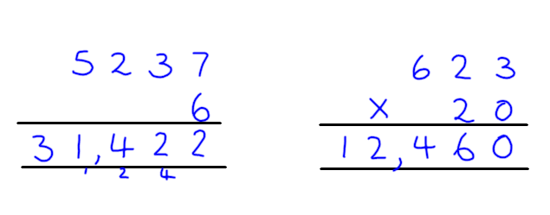 |  |  |  |  |  | 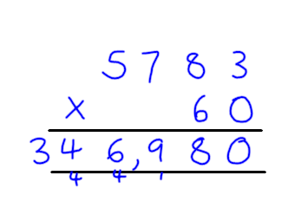 | Introduce multiplying by multiples of 10. Add a magic zero to move the answer up one column.
5 | 6 x 5237  20 x 623  60 x 5783  37 x 54  57 x 2653 | Short and long multiplication | 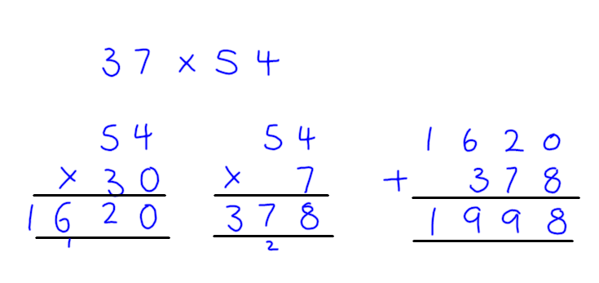 |  |  |  | 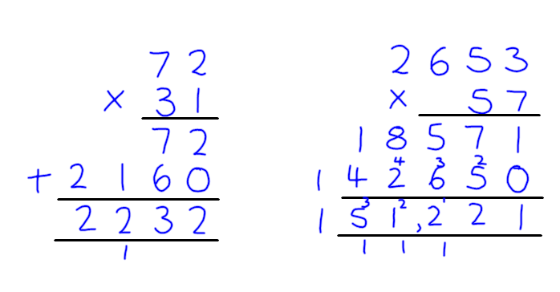 |  |  | Firstly, break up long multiplications into two products and then add the answers together. Then move to multiplying by 21, 31 etc. before full method
6 | 7 x 1.45 | Short multiplication of a decimal | 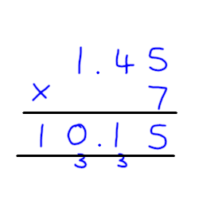 |  |  |  |  |  |  | In year 6, the only new material is multiplying decimals by integers.

÷ | William Barnes Primary School Written Calculation Policy 2016  Division
Year | Calculation | Numicon reference or calculation name | Progression in recording written calculations |  |  |  |  |  |  |  | Notes
2 | 50÷10=5  20÷5=4  12÷4=3 | Kit 2 Calc.17  Counting up strategy  Kit 3 Calc. 7 | 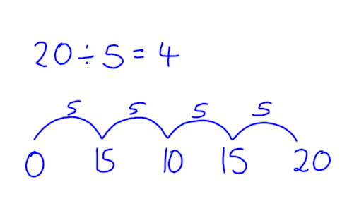 |  |  |  | 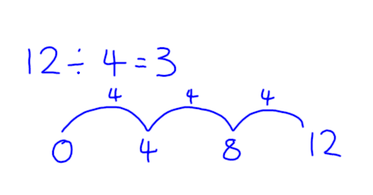 |  |  | Say “How many 10s in 50?”  Number lines for less able – support with apparatus
2 | 32÷5=6R2  17÷3=5R2 | Kit 2 Calc.18  Counting up strategy  Kit 3 Calc.7 | 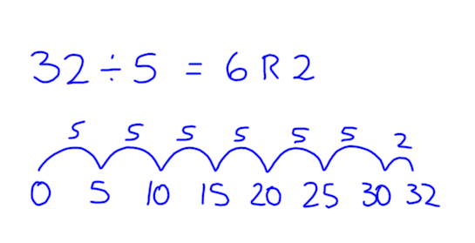 |  |  |  | 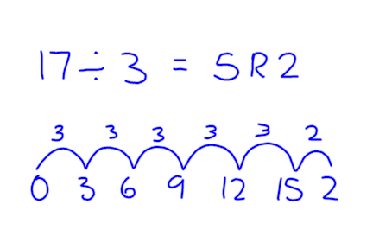 |  |  | Say “How many 5s in 32?” Make sure practical work is recorded with number lines
 | 10÷2=5  8÷2=4 | Kit 2 Calc.19  The sharing nature of division  Kit 3. Calc 11 | 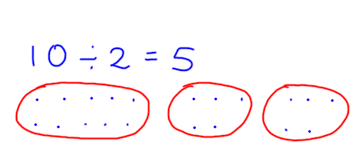 | 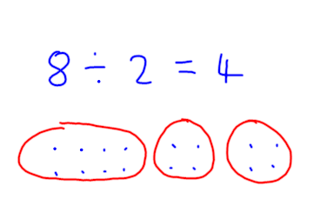 |  |  |  | Don’t record with number lines when sharing.  Say “Divide 10 into two equal parts.”  Say “Divide 15 into 3 equal parts.”  Sharing inefficient when group sizes and numbers increase e.g 64÷4
2 | 15÷3=5  22÷4=5R2 | Kit 2 Calc.20  Kit 3 Calc.11 | 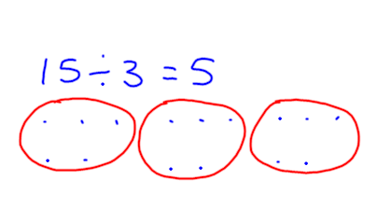 | 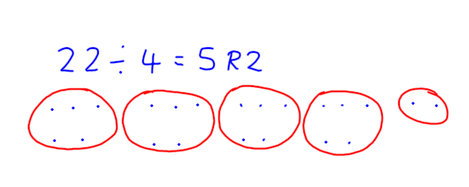 |  |  |  | Once children understand sharing, focus on counting up or repeated addition e.g “How many 4s in 44?” Once children secure with number line move onto short multiplication.
3 | 44÷4=11 |  | 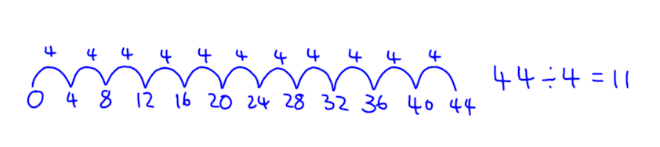 |  |  | 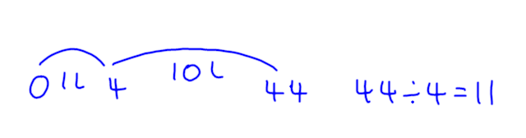 |  |  | Record using number lines – repeated subtraction
4 | 90÷8=11r2 |  | 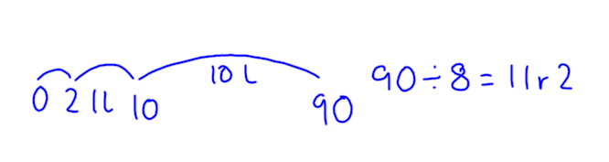 |  |  |  |  |  | Repeated subtraction on number line – first step for chunking
4 | 42÷3=14  185÷5=37 |  | 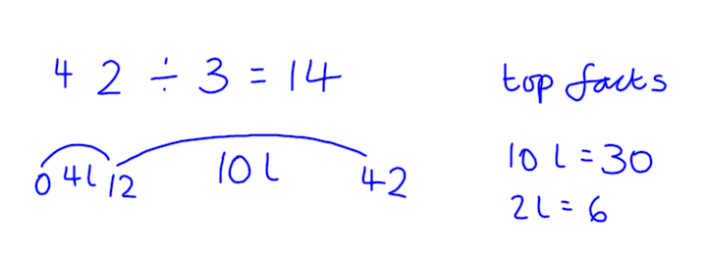 |  | 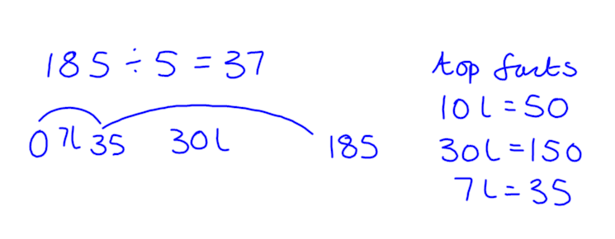 |  |  |  | Moving to larger chunks Write down “top facts”at the start . Record as l for “lots” to avoid using the multiplication sign.
5 | 224÷7=32  356÷6=59r2 |  | 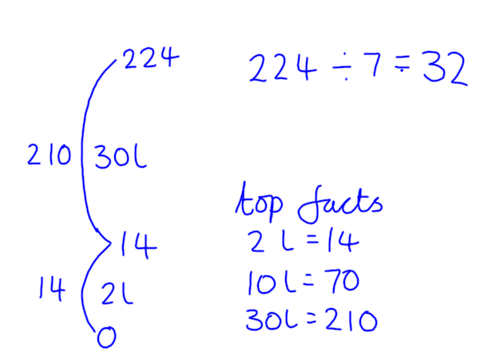 |  | 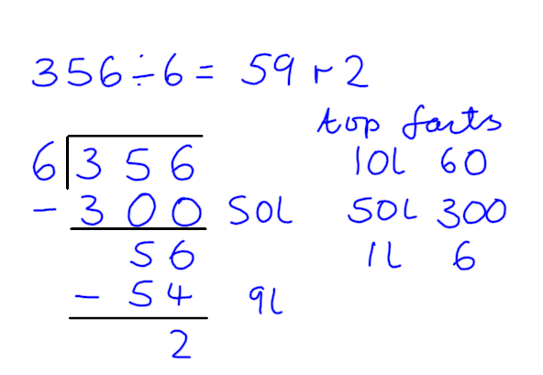 |  |  |  | Move to vertical number line then begin recording as column method. This is preparation for dividing by 2 digit numbers.
5 | 84÷4=21  165÷5=33 |  | 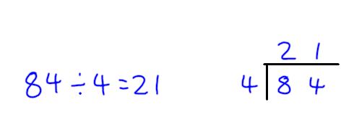 |  | 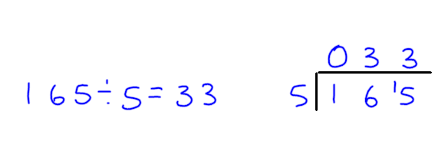 |  |  |  | Short division or “bus stop” method.  Use when dividing by single digit
5 | 226÷7=32.285  3444÷8=430.5 |  | 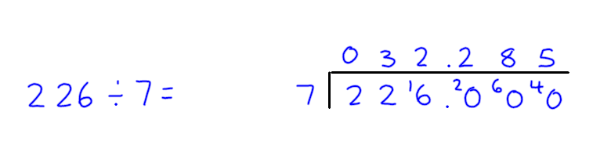 |  | 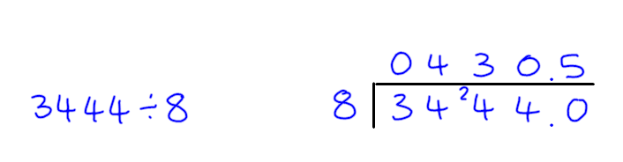 |  |  |  | Useful when dealing with remainders.
5 | 295.4÷7=42.2  183÷9=20.333 |  | 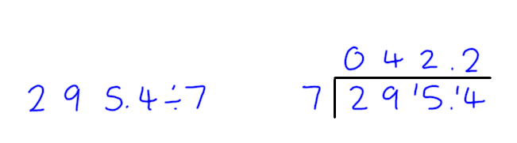 |  | 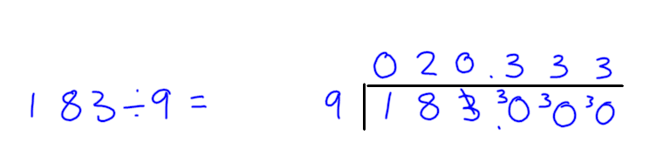 |  |  |  | Useful for exploring recurring decimals.
6 | 390÷32=12r6  4152÷22=816 |  | 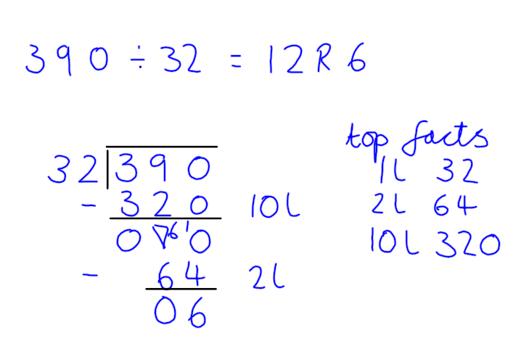 |  | 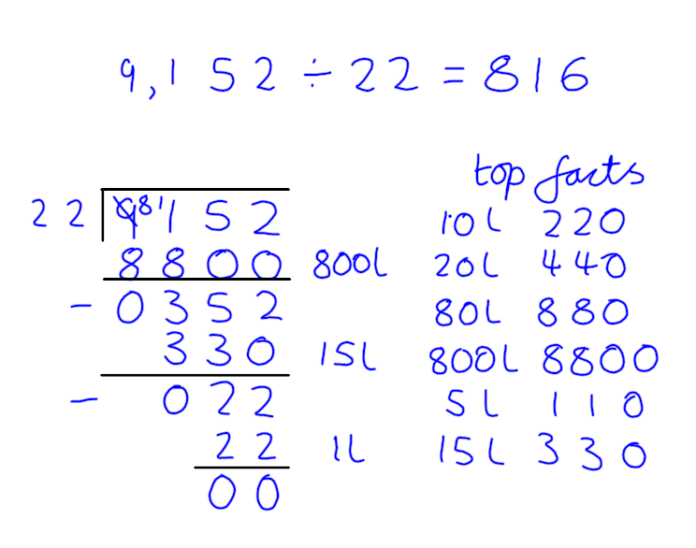 |  |  |  | Use chunking method when dividing by a 2 digit number.

+ | William Barnes Primary School Written Calculation Policy 2016  Addition
Year | Calculation | Numicon reference or calculation | Progression in recording written calculations |  |  | Notes
R |  | Firm Foundation 10a, 10b, 11a, 11b | 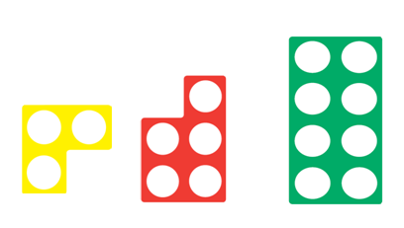 |  | 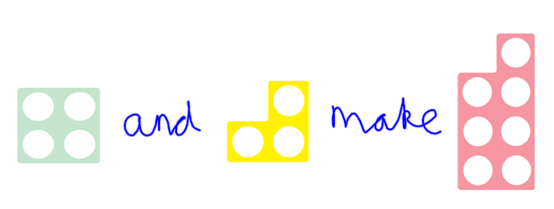 | Children choose two tiles and decide which tile is the same introducing addition.
1 | 6+2, 6+3, 6+4,6+5,6+6 etc | Kit 1 Calc 4A | 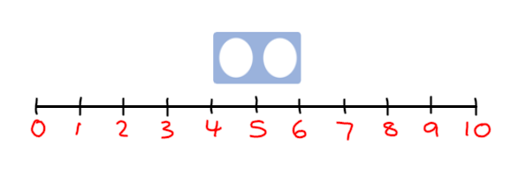 |  | 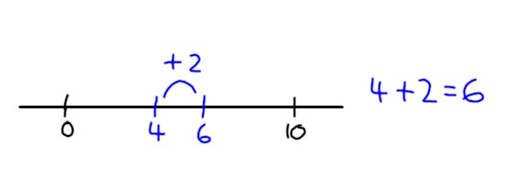 | Extend to adding 3,4,5 etc  First use of number lines
1 | 5+0, 8+0 | Kit 1 Calc 6A | 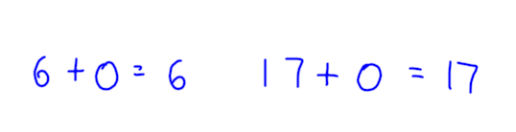 |  |  | Adding zero – crucial concept
1 | 1+9, 2+8,  3+7, 4+6,  5+5, 6+4,  7+3, 8+2, 9+1 | Kit 1 Calc 7B | 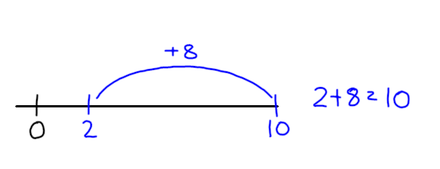 |  |  | Children memorise their complements to ten as part of their 55 club
1 | 4+3+6 | Kit 1 Calc 9A Adding 3 numbers using complements | 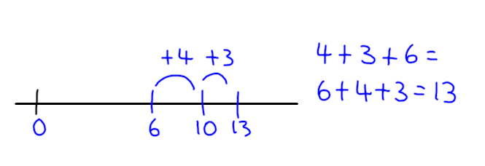 |  |  | Commutative law of addition  Children find pairs are complements to 10 before adding.
1 | 37 + ? = 40  72 + ? = 80 | Kit 1 Calc 12A | 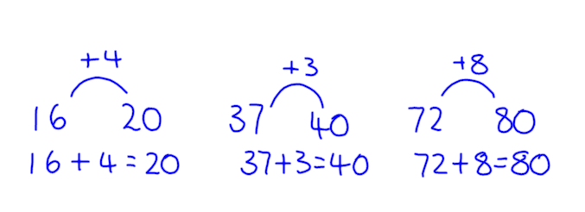 |  |  | Adding to nearest 10 prepares the children for bridging 10.
1 | 8+5 = 13  7+8 = 15 | Kit 1 Calc 13 A Bridging 10 | 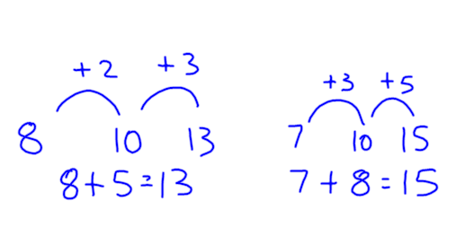 |  |  | Bridging 10 < 20 to begin with.
2 | 28+5 = 33  67+8 = 75 | Kit 2 Calc 7  Bridging 10 | 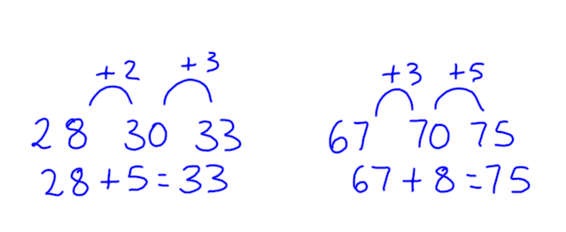 |  |  | Use apparatus including Numicon and Numicon IWB software to model
2 | 47+34 = 81 |  | 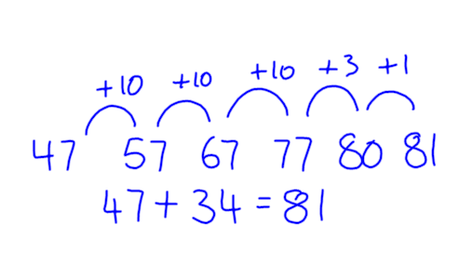 | 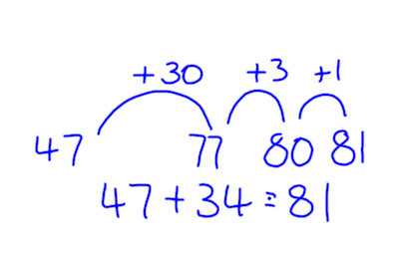 |  | Bridging numbers approaching 100
2 | 86+38 = 124 |  | 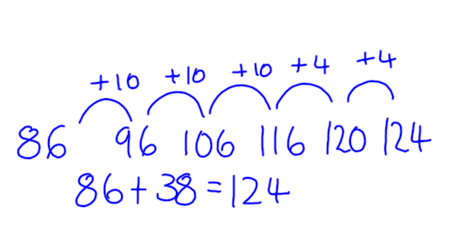 | 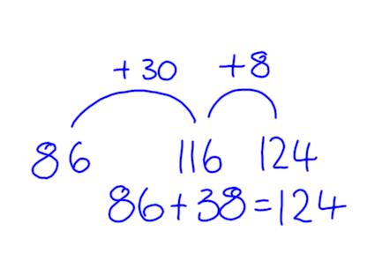 |  | Exceeding 100  Children now need to move to column methods
3 | 86+38  362+168 |  | 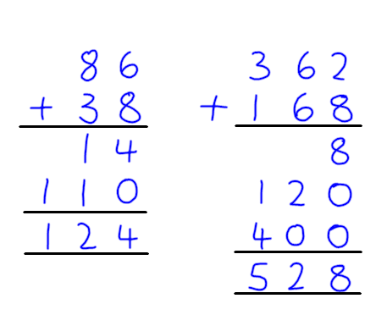 |  |  | Add the numbers mentally starting with largest number  E.g.  400 + 120 + 8  = 520 + 8  = 528
 | 372+168 | Expanded column method  Contracted column method | 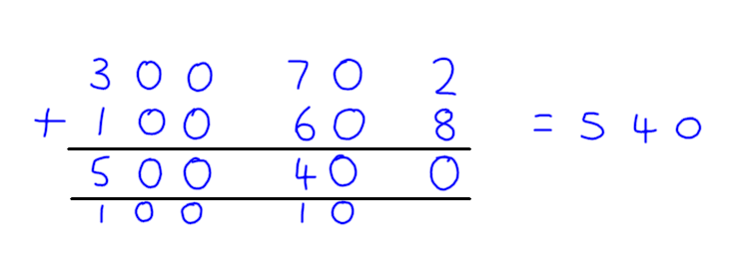  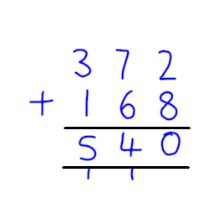 |  |  | Always start with the units first  Once children understand idea of carrying then move onto compact method  Carrying always below the answer box
4 | 3638+4542  1202 + 45 + 367 | Contracted column method | 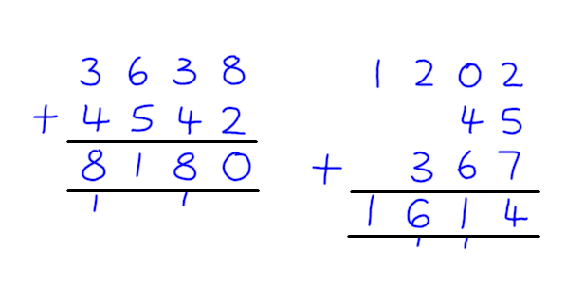 |  |  | Introduce numbers with different numbers of digits.  Add three or more numbers in columns.
5 | 78793+53628  53+3.12+2034 | Contracted column method | 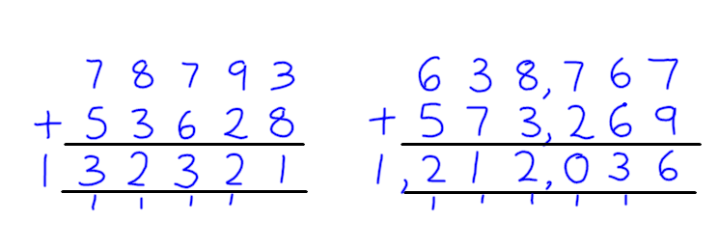 |  | 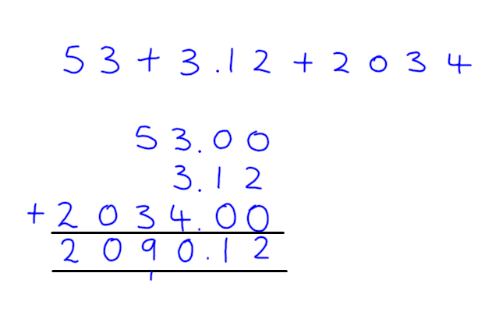 | Extending to adding 5 digit numbers  Then six and digit numbers  Adding numbers with different numbers of digits and decimal places
6 |  |  | No new content in Year 6 for addition

Adopted date: | 25/06/18
Signature of Headteacher: | Karen Wrixon
Signature of Governing body: | Maria Dixon
Next review date | Spring 2019

