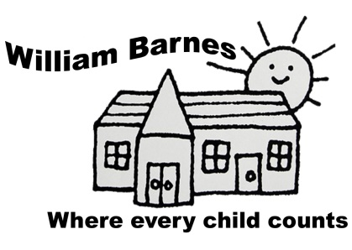
William Barnes Primary School Computing Policy
Generic INTENT

Vision |  |  | Mission
*An inspirational, stimulating and well-resourced environment  *A safe and secure school at the heart of the community  *Inquiry, independence and enthusiasm for learning |  | *Preparing all children for life  *A high quality professional team  *Taking pride in all our achievements  *High standards of behaviour | Where every child counts
Excellent teaching gives children the life chances they deserve...Enjoyment is the birthright of every child. The most powerful mix is the one that brings the two together. Children learn better when they are excited and engaged – but what excites and engages them best is truly excellent teaching. Education is for all, not the few. All children have the right to be the best they can be. We foster a love of learning and the development of the well-rounded child.
Preparing Children for Life
We believe that we are preparing children for 21st Century life. We aim for them to be independent thinkers, confident learners and global citizens, equipped to live and work in and contribute to the global economy.

Aims and Objectives
At William Barnes Primary School, we believe that children deserve:
- To be set appropriate and stimulating learning challenges
- To be taught well and be given the opportunity to learn in ways that maximise the chances of success
- To be given quality feedback which highlights successes and areas for improvement.
- To have adults working with them to tackle the specific barriers to progress they face.
It is also our aim that :
- Children develop a lasting love of all aspects of learning which will aid and enhance their further education and life.
- Children are given the opportunity to experience the widest variety of the written and spoken word possible - a vocabulary rich curriculum and school experience. This includes trips to pantomimes, art galleries and orchestral concerts.
- Children develop a healthy lifestyle this is supported by Active Learning, The Daily Mile, Wake and Shake and a robust healthy eating policy.
Knowledge and Skills
As a school, we believe in the equal relationship between knowledge and skills in our curriculum.
We believe that:
- Knowledge can be declarative ( to know that ) or Procedural ( to know how ).
- Both these forms are important and that Declarative knowledge is turned into Procedural knowledge.
through action and the act of applying.
- Skills can be Procedural knowledge as a result of the application of Declarative knowledge.
- Skills can be linked to dispositions and behaviours.

In short, skills often procedural knowledge and are linked intrinsically to declarative knowledge.
We prefer to see the debate laid out as:

Knowledge Comprehension Application Evaluation

Global Community  We aim to equip our children for living in, and contributing to, a secure, transformative and sustainable world. | Parents  “For all children, the quality of the home learning environment is more important for intellectual and social development than parental occupation, education and income. What parents do is more important than who parents are.” (EPPE)

Computing INTENT

Introduction

Our vision is for all children to be confident and safe e-learners. At William Barnes, the children’s safety when using information technology is paramount and the school’s computing policy is underpinned by our commitment to E-safety. (Please see E-safety policy)

Computing at William Barnes has three interconnected aspects. Firstly, children learn the principles of information and computation and how digital systems work, and how to put this knowledge to use through programming. Secondly, the children build on this knowledge and understanding to become equipped to use information technology to create programs and content. Finally, the children need to become digitally literate so that they are able to use, express themselves and develop their ideas through information and communication technology (ICT) preparing themselves for the future work place.

At William Barnes, the increased emphasis on programming or coding in the 2014 national curriculum is welcomed and has been reflected in our scheme of work.

Long Term Aims

At William Barnes we aim to offer a broad and stimulating Computing curriculum which encompasses all areas of study outlined in the National Curriculum. By setting appropriate challenges we aim to prepare pupils to participate in a rapidly changing world, in which we work and other activities which are increasingly transformed, by access to varied and developing technology. We aim to provide the opportunity and tools to enable pupils to find, analyse, exchange and present information responsibly, creatively and with discrimination. William Barnes is committed to an Equal Opportunities Policy, and we aim to ensure that all pupils receive the same experiences.

E-Safety

Children are required to read, understand and sign a responsible use form. See the School E-Safety Policy for more details.

Aims

To enable each child to develop their computing skills, to aid their learning and in preparation for use in work and the outside world.

To promote and encourage use of initiative and independent learning where the children are able to understand, apply, analyse and evaluate their knowledge and understanding of computing and information and communications technology.

Current Practice

Computing is taught as a discrete subject and a cross curricular tool throughout the school from reception to year 6. IT and computing is timetabled so that staff can guarantee that all the devices they will need are available.The school has a network with a central server that stores children’s work. Each child and member of staff has an account which is accessed using a username and password. To use the school network, children must use one of the school laptops. These are stored centrally in two computer trolleys. The school also has a set of iPads. These do not require passwords for access. Children and staff do not store work on iPADs and any images and videos are transferred to the school network and then deleted from the iPADs for GDPR reasons.

Teachers use IT to deliver their lessons using a variety of interative white boards (IWB). Each teaching area has an IWB and there is also a further IWB in the Butterfly room which is particularly used to support phonics

SEND/Vulnerable Groups/EAL
Special educational needs and disabilities:

- Children with AEN, SEN and Higher Achieving Children have activities differentiated to their individual needs.
- Children with SEN issues linked to Computing will have targets included in their IEPs.
- Teaching is be sufficiently differentiated to meet the needs of all children.
- Because of the difficulties associated with logging in, children will often use a single class password in year 1 and Reception.
- Specific skills for computing could be included in an IEP and additional time needs to be available for the teaching of these.
- The setting of IT based tasks for home learning should be done recognising that some children from vulnerable groups may not have access to digital learning outside of school.

Equal Opportunities

- Computing is taught within the framework of the school’s equal opportunities policy.

Teachers Responsibilities.

Whilst teaching Computing and IT children are given the opportunity to:

- Use technology safely and responsibly and learn about E-Safety through the PSHE curriculum.
- Learn how to keep themselves and children safe when using the internet and recognise and know what to do when it is not safe – see E-safety policy.
- Develop hand eye co-ordination using a mouse or mouse pad, keyboard, touch screen to move the pointer on the screen.
- Operate various ICT tools, which include laptops, tablets, digital cameras, digital sound recorders, digital microscopes, sensors, CD ROMs, interactive whiteboards, Roamers and Lego Wedo.
- Collect, process, store and retrieve information.
- Communicate ideas through text, graphics, charts, sound and video for a variety of audiences.
- Evaluate the experience of using ICT compared with other forms of communication.
- Select suitable media to develop their ICT capability and knowledge.
- See and compare ICT at work in the community.
- Develop, question and explore ideas.
- Plan a set of instructions, enter them into the computer and manipulate them to achieve a desired end.
- Detect patterns and relationships and form and test simple hypotheses.
- Co-operate in pairs or small groups, to make joint decisions and persevere with a task.
- Learn to write code using software such as Logo, Scratch and Kodu
- Learn to debug code until a program functions effectively
- Be discerning about information obtained from the internet and be able to evaluate its accuracy and intent.

When teaching Computing staff
- Give all children at William Barnes access to all areas of Information and Communications Technology (ICT) with a particular focus on coding.
- Enable each child to develop their potential skills, to aid their learning in preparation for use in work and the outside world.
- Promote and encourage use of initiative and independent learning where the children are able to make informed judgements and choices.
- Use the computer to support and develop other learning which is taking place within the classroom using computing as a cross curricular too.
- Enable children to work together, collaborate and share ideas.
- Use direct class teaching to introduce a specific program or skill.
- Teach through practical tasks using the appropriate hardware and software.
- Plan group activities, so that children can interact with each other.
- Provide children with real experience in the practical application of computing and coding skills.
- Use of the Scheme of Work based on the code-it approach produced by Hampshire advisor Phil Bagge available on line at code-it.co.uk.
- Give children the choice to use computing where possible for a specific purpose perceived by the child.
- Develop ICT skills in line with the code-it scheme.
- Enhance topic work as support in other curriculum areas.
- Record and review work in other subjects.
- Post homework tasks on Mathletics and Time Tables Rockstars (see Maths Policy).
- Assess children’s progress against the programmes of study for Computing as laid down in Curriculum 2014.
- Teach children how to be E-Safe in line with the school’s E-Safety policy.

Planning and Assessment

Each member of staff is responsible for planning Computing work to meet the needs of the children in their class in line with planning policy and the 2014 Computing Curriculum. Teachers use the code-it scheme of work, and statutory and non-statutory guidance to help inform their planning, as well as other on line resources such as Twinkl to create their planning. At William Barnes class teachers are responsible for their own class organisation and teaching style in relation to computing, however, these should reflect the overall aims and philosophy of the school. Teachers keep their own records of their class’s progress and use these to inform their end of year reports to parents. Children are judged annually as to whether they are working towards age related expectations (ARE), working at ARE or exceeding ARE and this information is stored with the school’s online tracking system Educater.

Resourcing and Equipment

Staff take equal and shared responsibility for the recharging and care of the school’s set of iPADs and laptops. Keys are kept centrally in the office and devices are returned after each lesson to either the POD or Governor’s room for storage and recharging.

As far as possible, each member of staff is provided with a laptop to dispense their duties as teachers only and these are not for personal use as is outlined in the staff code of conduct.

IT Technician Support

All issues regarding the efficacy of the school network should be recorded on the online support request portal found on the desk top on each of the laptops During his fortnightly visits the technician uses these to prioritise his tasks. Pressing issues can be reported to the Computing coordinator, who can notify the technician, who may be able to resolve the issue remotely between visits.

Security

Staff have a duty to ensure that their passwords are kept safe and not shared with children or anyone who could compromise the security of the school network. All data is either stored on the network server and transferred either using Office 365 One Drive or using encrypted data sticks that are password protected.

Planning

- Long term and medium term planning is in line with Curriculum 2014 and is used as part of the connected curriculum.
- Each term a class will be taught a broad and balanced curriculum consisting of the development of coding skills and the use ICT as a cross-curricular tool.
- Weekly planning follows an agreed proforma and generic principles.
- Broad Learning Intentions from Curriculum 2014 are broken down in the smaller, appropriate
Learning Intentions. Success Criteria, required exposition and linked differentiated activities are also
included.

OVERVIEW
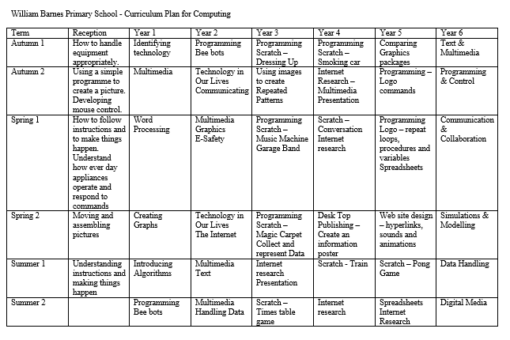
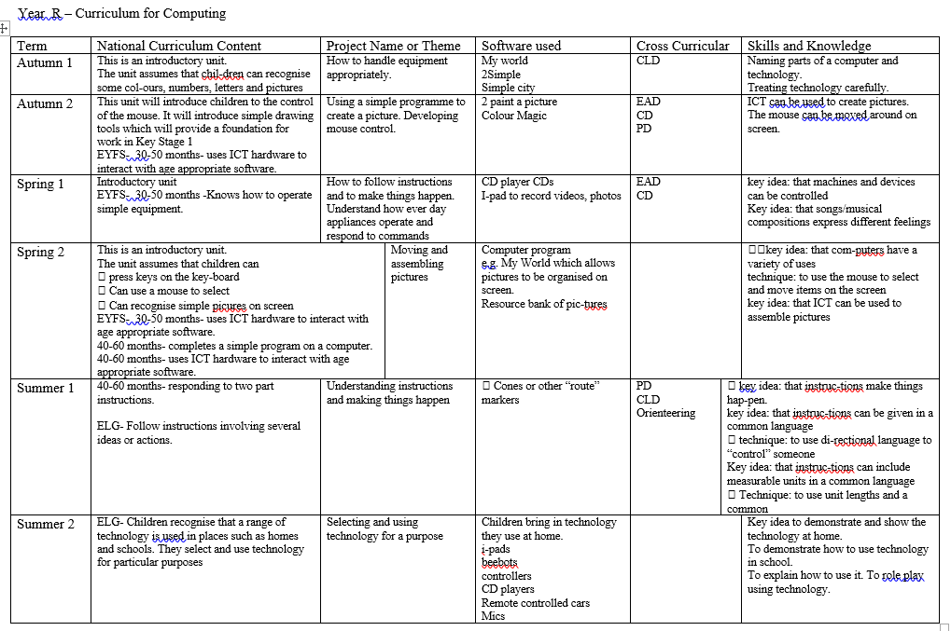

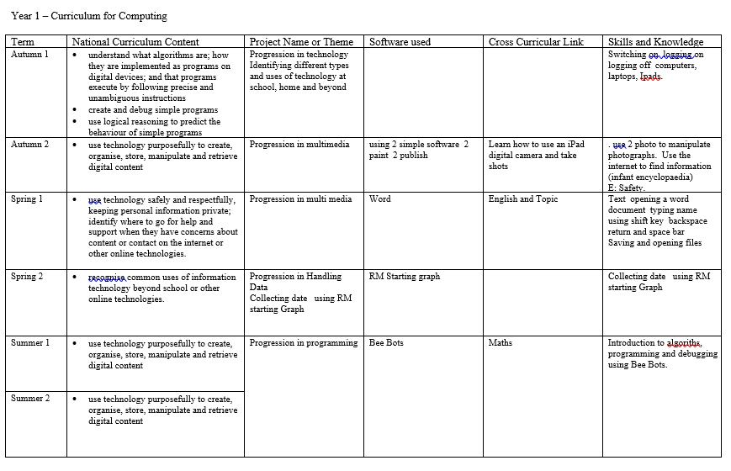

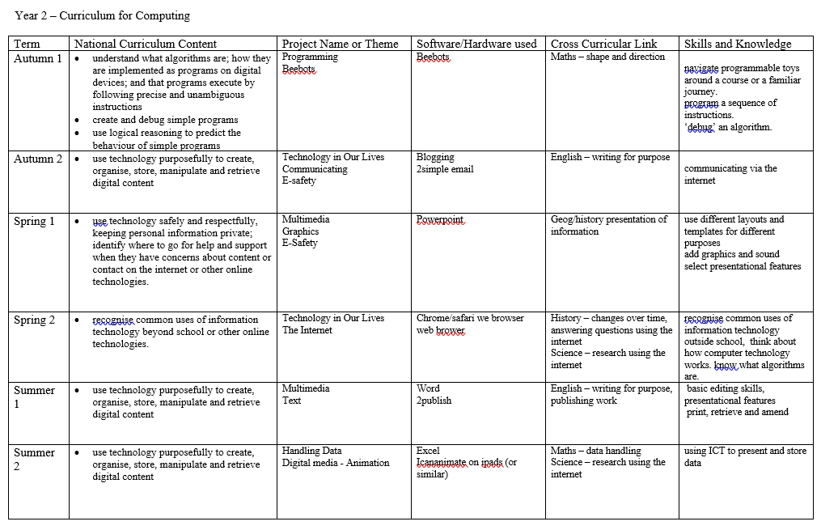
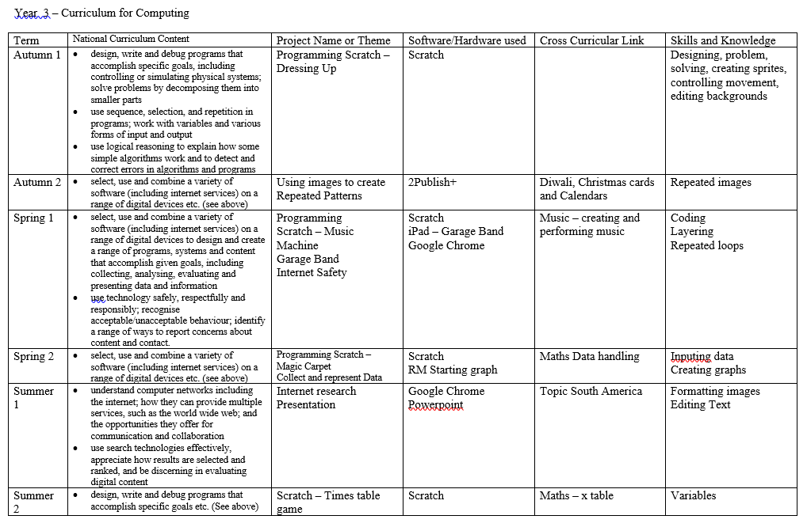

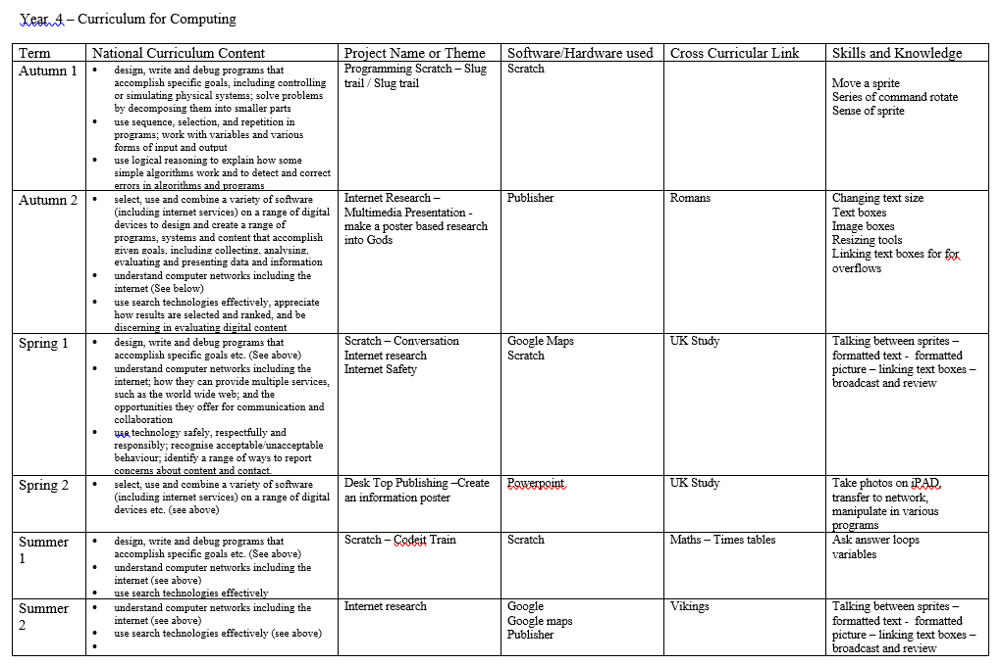
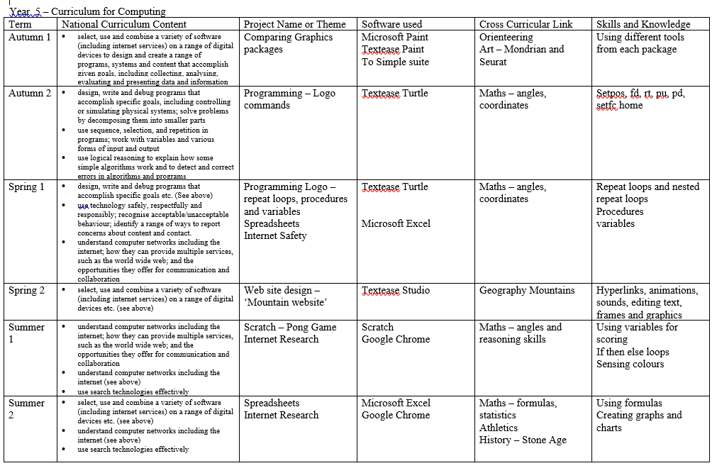
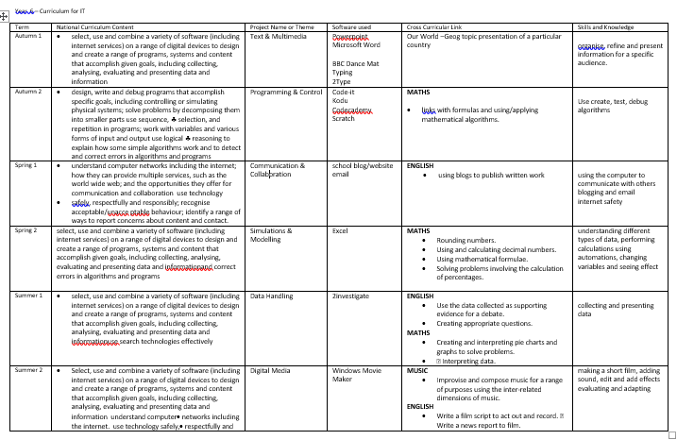

IMPLEMENTATION

How We Teach

Computing is normally taught as a discrete whole class lesson but it is also used as a cross curricular learning tool. In computing lessons, children will be taught new skills at the start of the lesson, (often during the time that laptops connect to the network). A recap of previous learning is often delivered by the children, particular in older year groups, with children coming up to the front of the class and modelling their understanding using the IWB. Once new skills have been explained, children will apply this to a task using either a laptop or an iPAD. The children will work individually or collaboratively in pairs. Lessons are n drawn to a close when children demonstrate and recap the learning that has taken place in the lesson, before next steps are discussed. Children are normally organised into flexible mixed ability groups that often change.
More Able
Able children are often used as experts helping children who have become stuck and freeing up the teacher to support other children. More able children can also be given further challenges, or more complex tasks to begin with. More able children can often be used as excellent demonstrators in the initial input, or during later mini plenaries and the final summing of the lesson. More able children may not always need to listen to the main input of the lesson and can start straight away whilst other children are still listening. Children who are more able in Computing often make unexpected discoveries in lessons about how a piece of software functions and these should be valued and shared with the rest of the class.
DT Lego Leaders
In year 5, children who are socially skilled and more able in computing are training to become Lego Leaders. Using the Wedo software, they are given some time with the Computing leader to learn how to use the Wedo iPAD app and the associated Lego kits. Each Leader takes responsibility for a kit and its maintenance. Once trained these children guide other children in the class with using Lego Wedo as part of the design technology curriculum and ensure that the equipment is well maintained and stored correctly.

Parents
At William Barnes Primary School, we believe that parents and teachers working together is highly beneficial to long term quality learning. When children complete IT based learning using Mathletics and Times Tables Rockstars.

IMPACT

Assessment

Formative Assessment
Children are assessed in Computing during lessons using AFL strategies (See AFL policy) and support provided as required for children struggling and for more able children who require additional challenge. Although teachers and teaching assistant will endeavour to help children who are finding work challenging, children who have mastered a particular skill can also be used as experts to support other children. Teachers keep informal records of the children’s progress in mark books and assessment folders.

Summative Assessment
Summative assessments are completed annually. Children are assessed against the expectations for their year group and are judged to be either working towards age related expectations (ARE), working at ARE or exceeding ARE. This information iss shared with parents in each child’s annual report using a grading system. Grade A is given for exceeding ARE, grade B for working at ARE and grade C for working towards ARE. Children are also given a grade from 1 to 5 to show their effort in Computing, with 1 indicating a low level of effort.

Support
Whenever possible staff are trained in Computing within the school due to budgetary constraints. A culture of collaboration exists amongst staff who often help each other by sharing areas of expertise. Particular IT skills and new developments are shared in scheduled staff meeting slots. Curriculum and technical support is also available through the school’s IT support contracts with TurnItOn which include a telephone helpline and help portal. The IT leader is always on hand to support staff with any computing issues where possible.

Monitoring
The monitoring of standards in Computing is undertaken by the Senior Leadership Team (SLT) and the Computing leader. At present, learning is scrutinised by the SLT to ensure continuity and progression. This will become more rigorous when staff have agreed expectations for storing work across the school. (See future developments).

Governors

- There is a member of the Governing Body with overall responsibility for E-Safety.
- Whole school attainment data for Computing is shared with the Governing Body.
- Governors are kept up to date with any developments/decisions at Governing Body meetings.

Future Developments

- Explore the use of Office 365 account for children to promote collaboration between children on projects.
- Explore the use of KODU as a coding language.
- Agreeing with staff expectations for storing Computing work for in school moderation and how this should progress across the school.

Richard Hull
May 2020

Originated by……Richard Hull Date 6th February 2017 …..

Adopted date: | 6th July 2020
Signature of Headteacher: | Karen Wrixon
Signature of Governing body: | Cliff Walters
Next review date | Summer 2021

